**CASE STUDY**

**Problem Statement:**

You work for XYZ Corporation and based on the expansion requirements of your corporation you have been asked to create and setup distinct Amazon VPC for production and development team.

You are expected to perform the following tasks for the respective VPCs:

**Production Network:**

1. Design and build a 4 tier architecture

2. Create 5 subnets out of which 4 should be private with names app1, app2, dbcache and db and one should be public named web.

3. Launch instances in all subnets and name them as per the subnet that they have been launched in.

4. Allow dbcache instance and app1 subnet to send internet requests

5. Manage security groups and NACLs

**Development Network:**

1. Design and build 2 tier architecture with two subnets named web and db and launch instances in both subnets and name them as per the subnet names.

2. Make sure only web subnet can send internet requests

3. Create peering connection between production network and development network

4. Setup connection between

**Solution:**

**Production Network**:

1. Creating VPC named as ProdVPC with 5 subnets (4 Private 1 public)

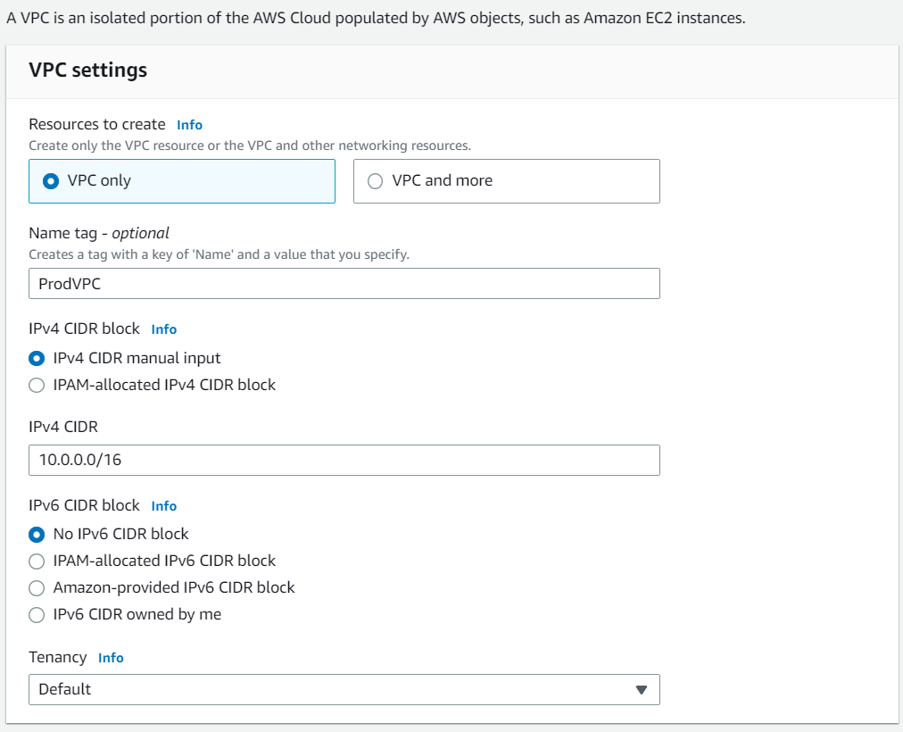

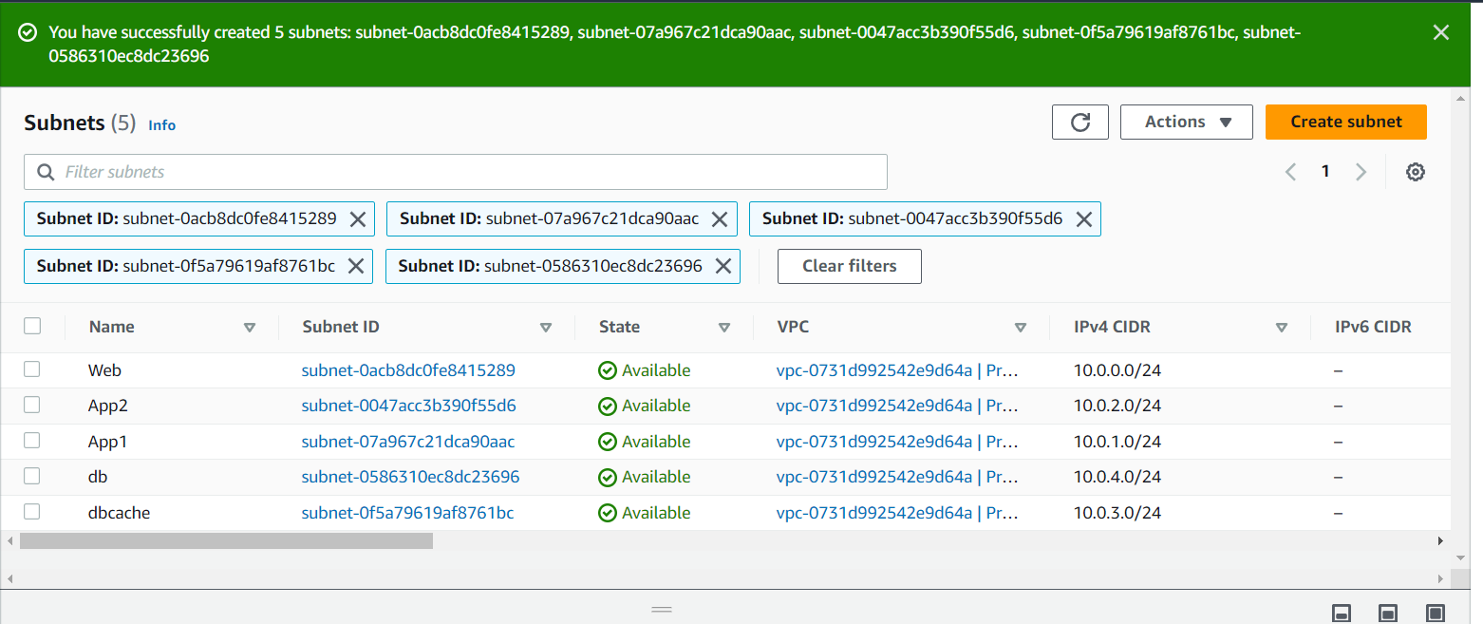

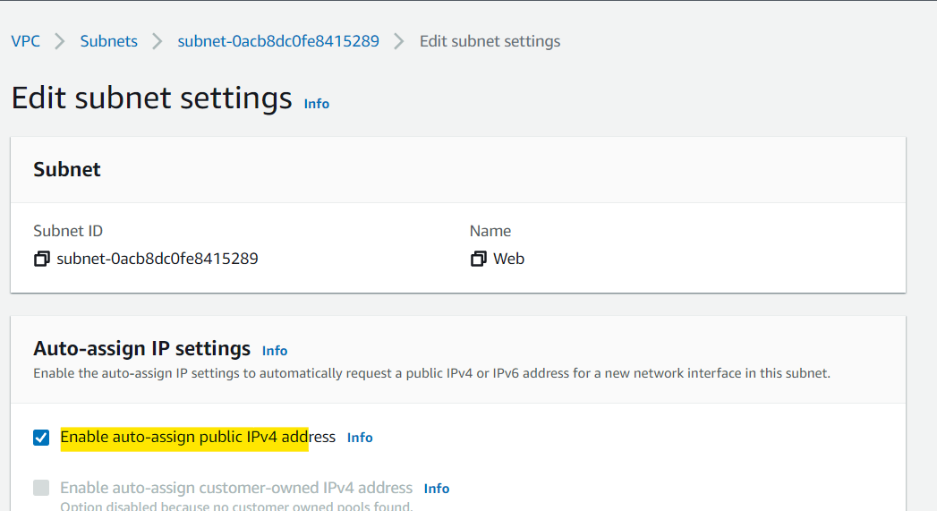

1. Internet Gateway creation and custom route table and associating with public subnet Web

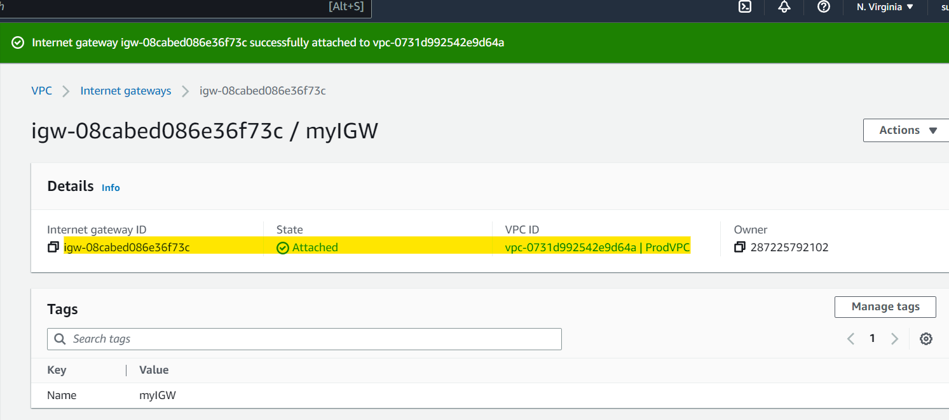

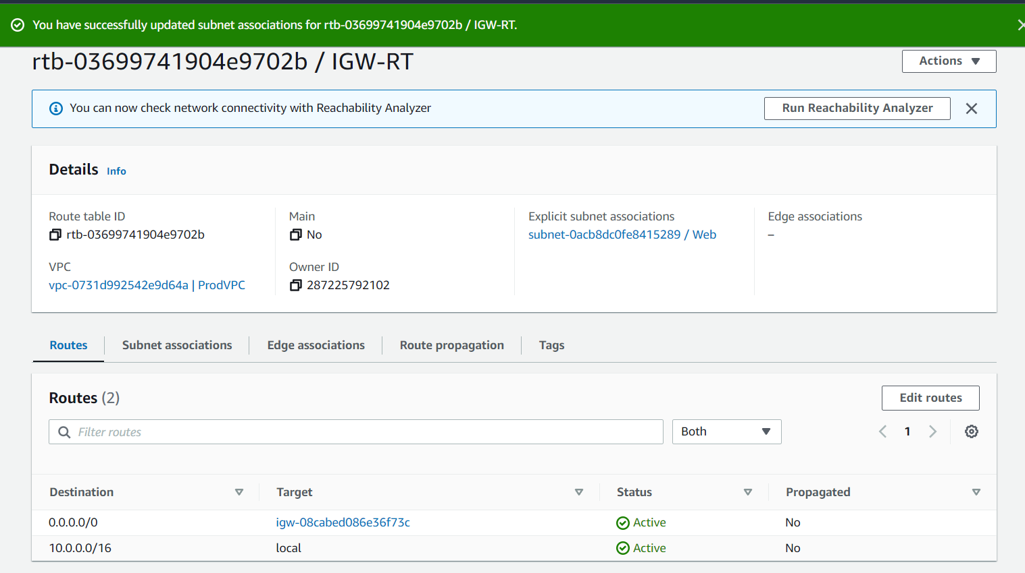

1. Launching instances in all the subnets:

Web-VM1:



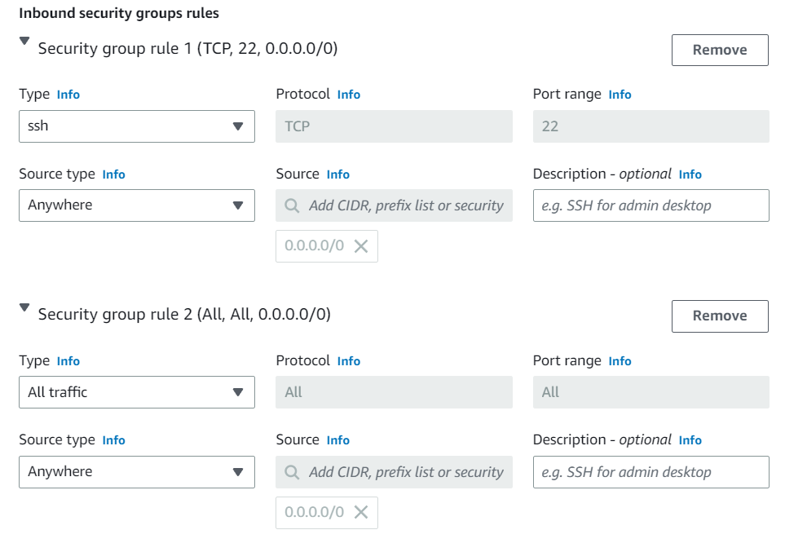

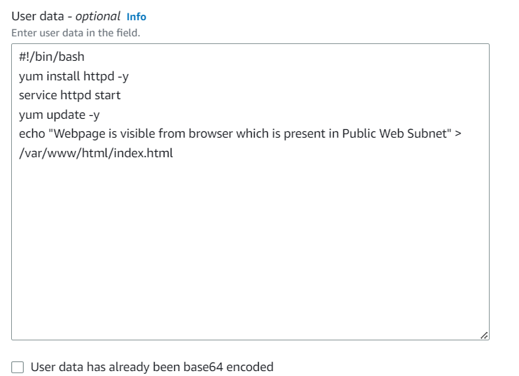



Able to connect Web-VM1 :

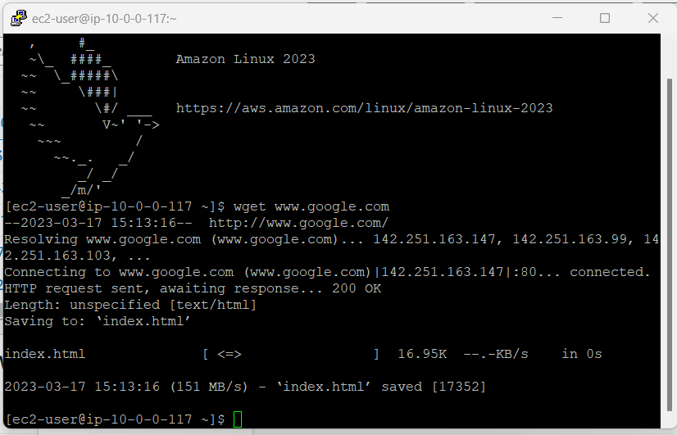

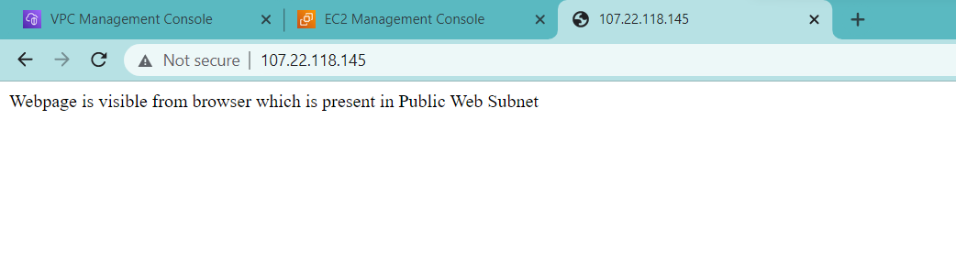

1. Allow dbcache instance and app1 subnet to send internet requests

Creating NAT Gateway for internet connectivity:

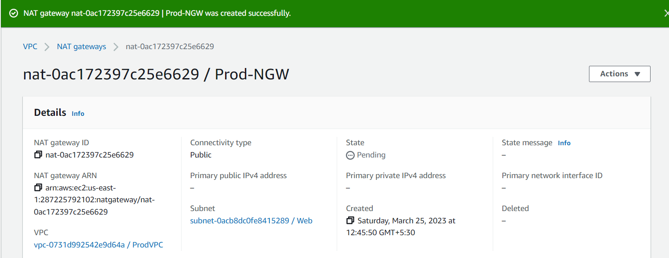

Route Table and editing inbound rule as destination internet and target NAT GW

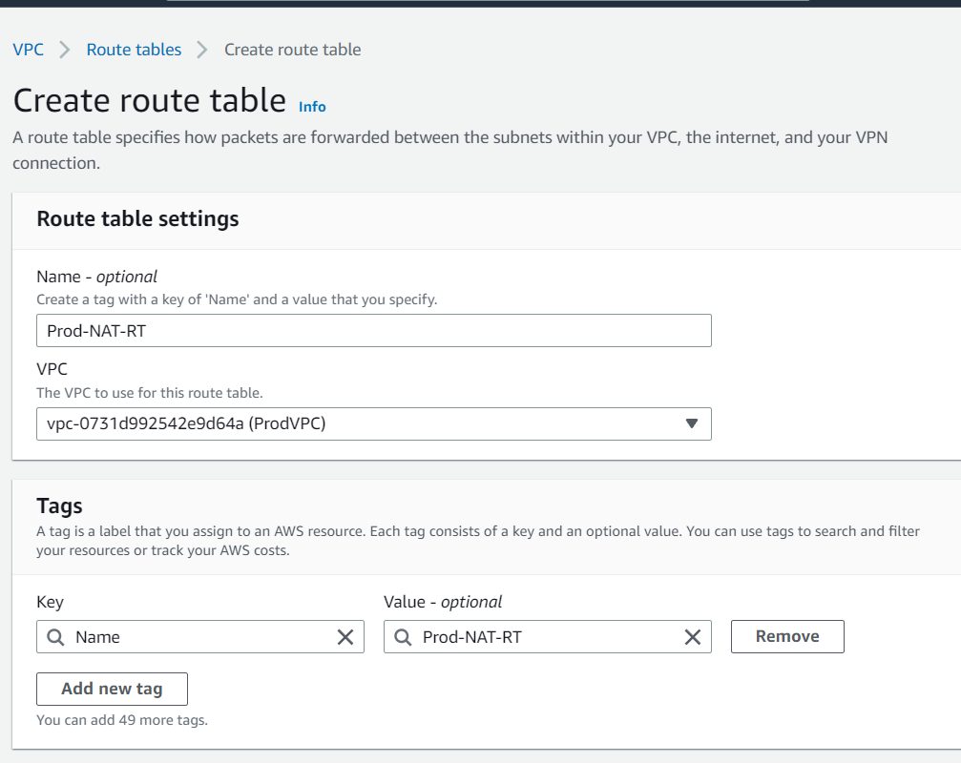

Associating Subnets dbcache and app1 to Prod-NAT-RT route table

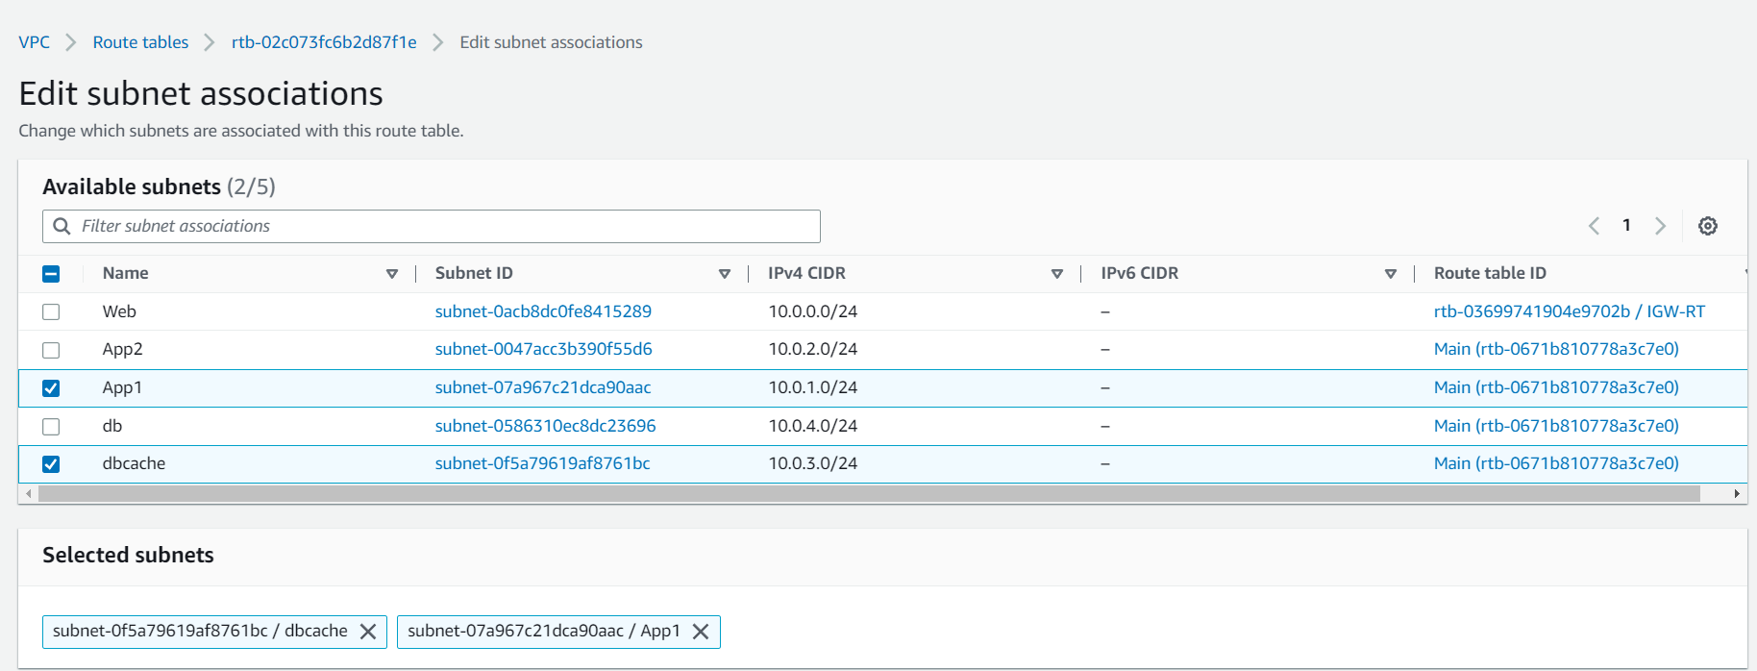

Security group with inbound rule **as *ssh from public subnet CIDR*** in order to connect ssh from Public VM and Outbound rule as ***all Traffic from 0.0.0.0/0*** that is internet

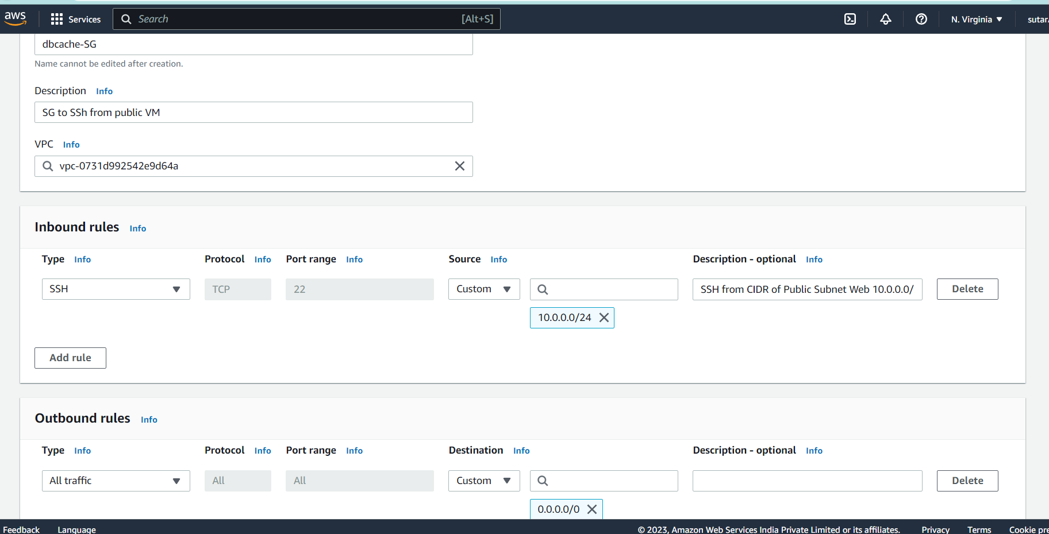

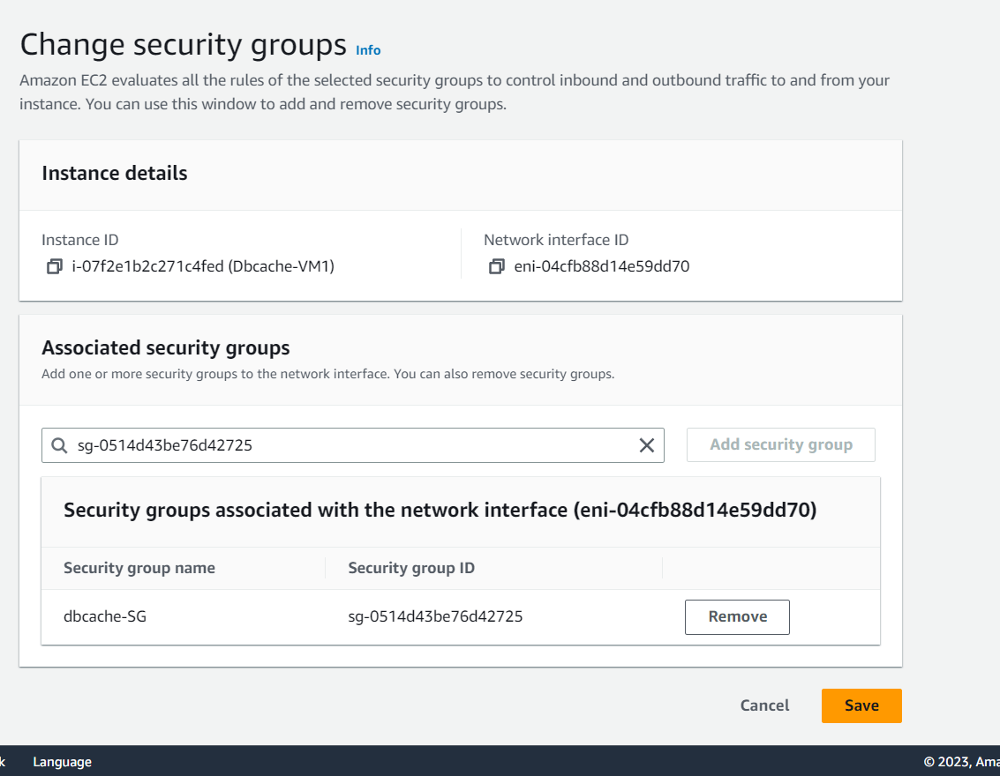

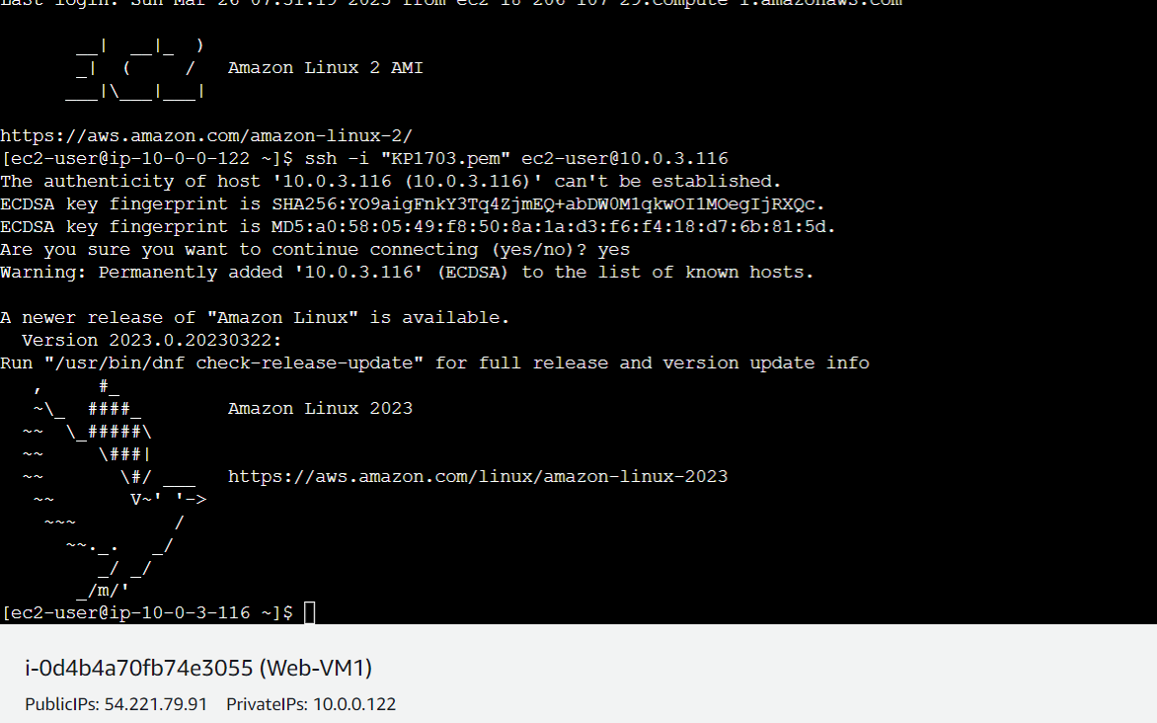

Able to connect internet from dbcache-VM1 Instance

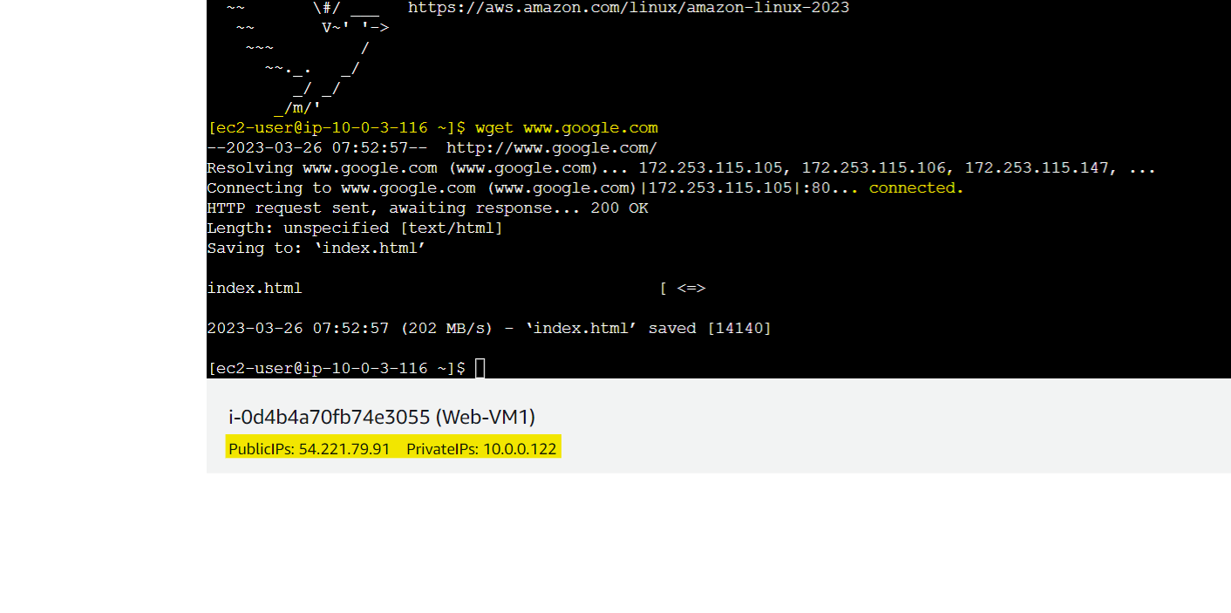

Creating another Security Group with inbound rule as ssh from public subnet CIDR

And Outbound Rule as NULL i.e. No Outbound Traffic

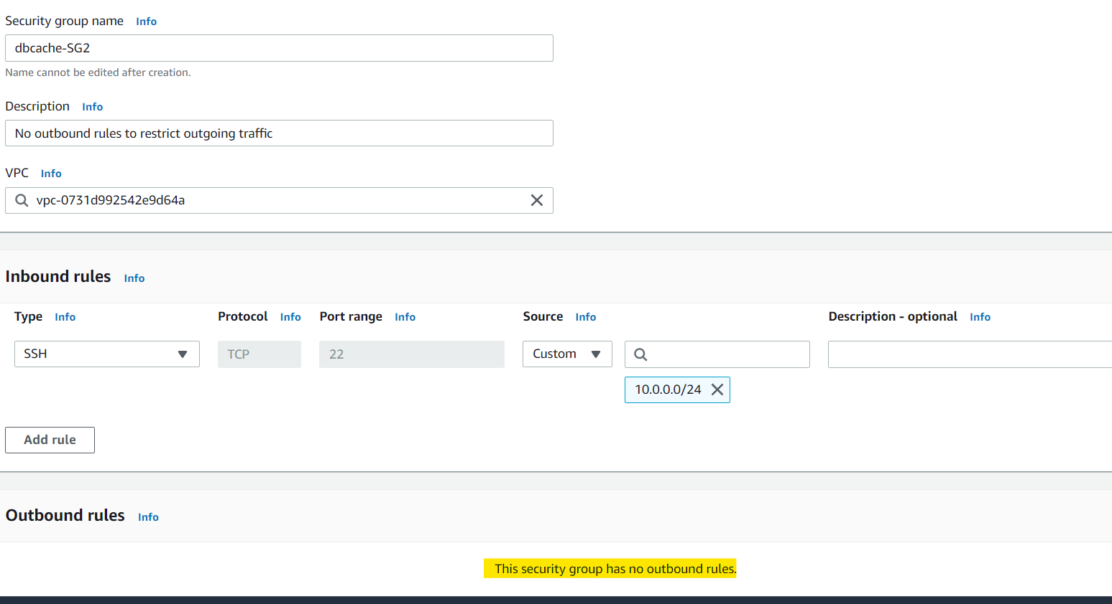

Changing SG of dbcache-VM2

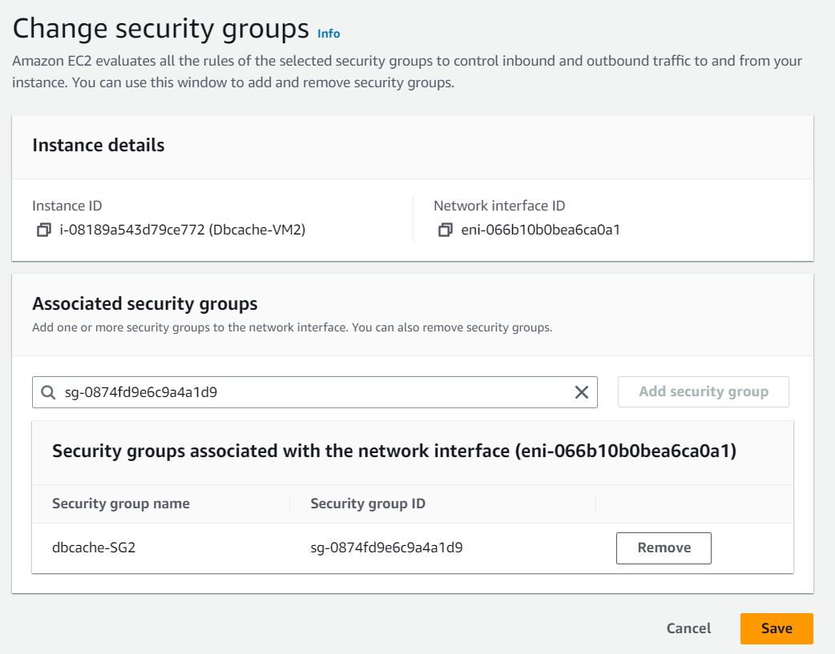

Connecting to dbcache-VM2 instance through Web-VM1 instance and trying to connect internet which will fail because of the SG settings of no outbound rules:

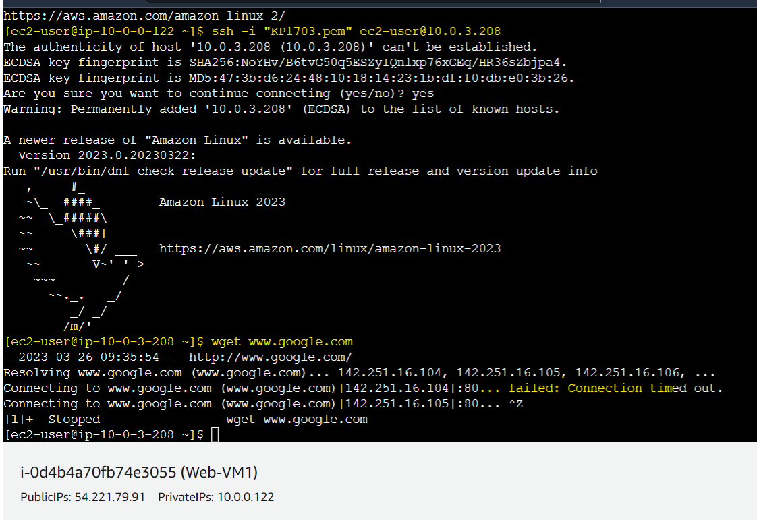

Hence only dbcache-VM1 instance is having internet connectivity through NAT gateway.

Allow app1 subnet to send internet request:

Editing inbound and outbound rule of App1-VM1 instance as follows:

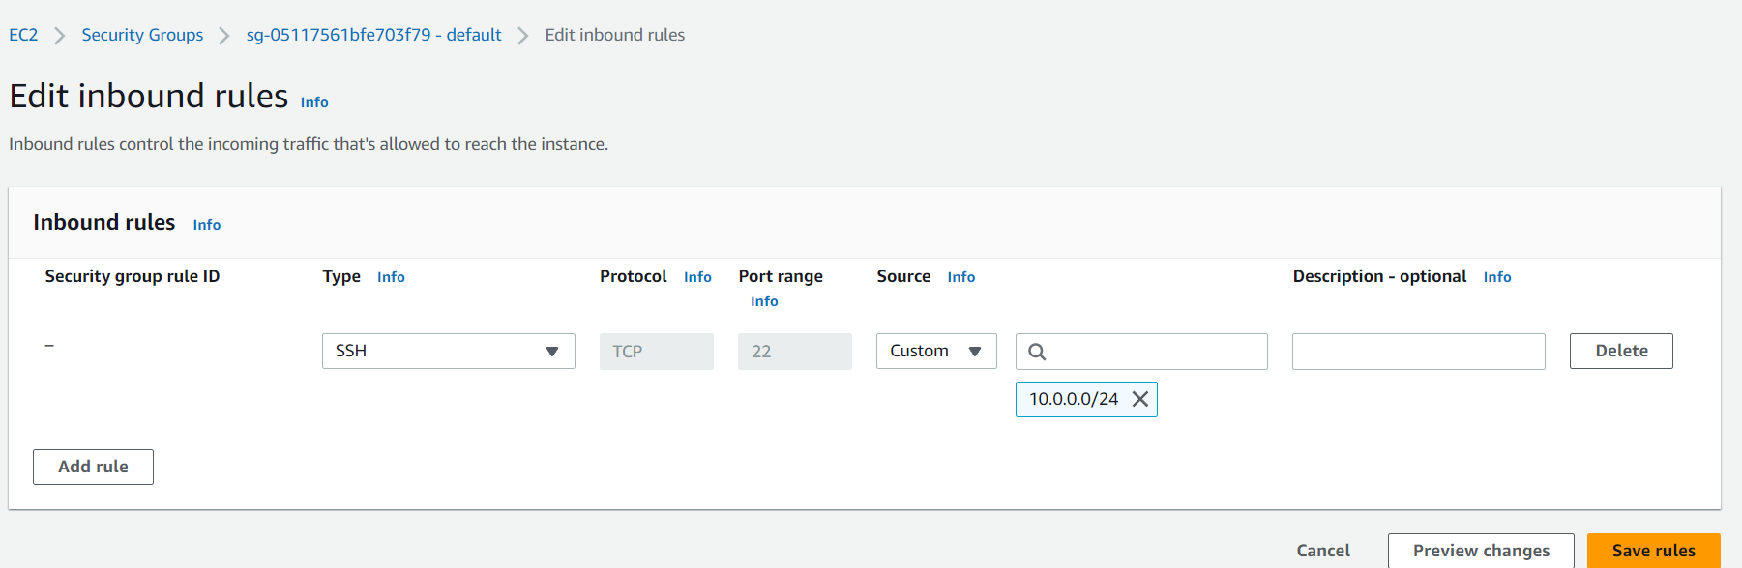

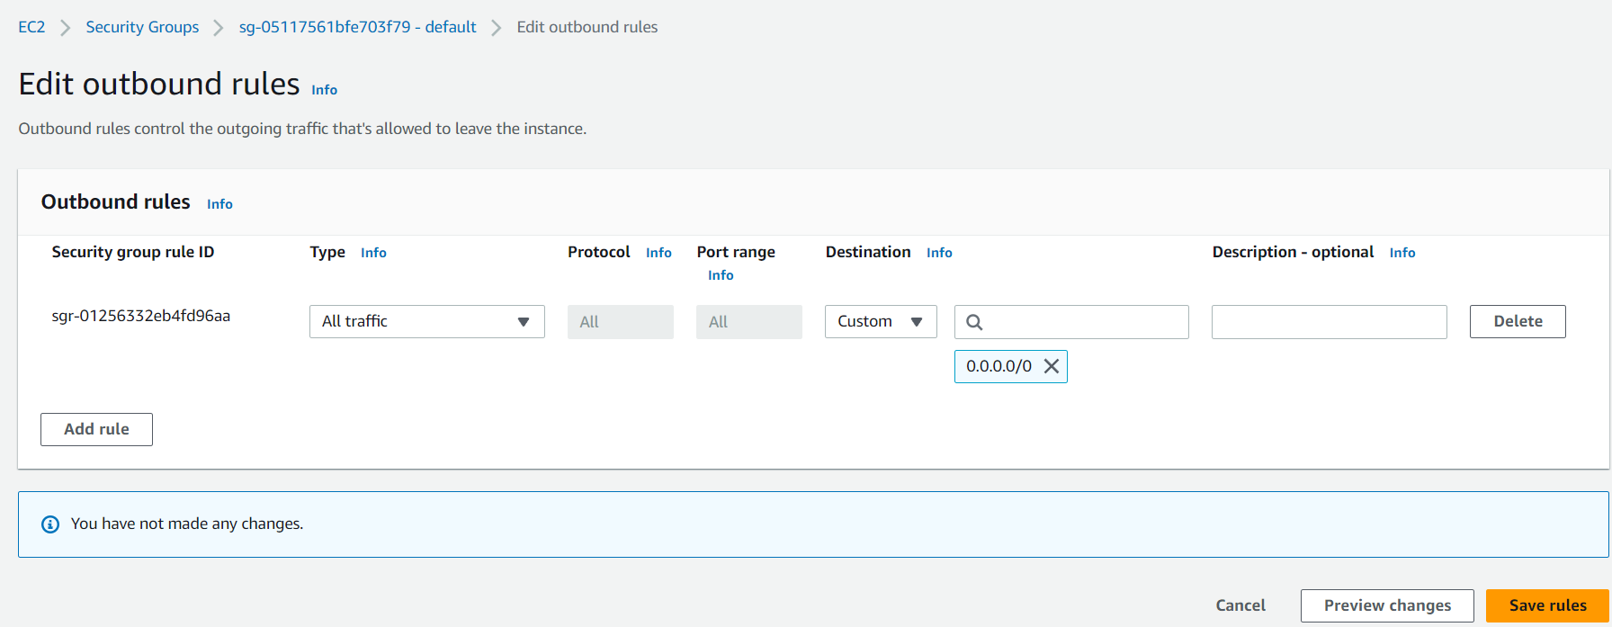

Internet connectivity established app1-vm1

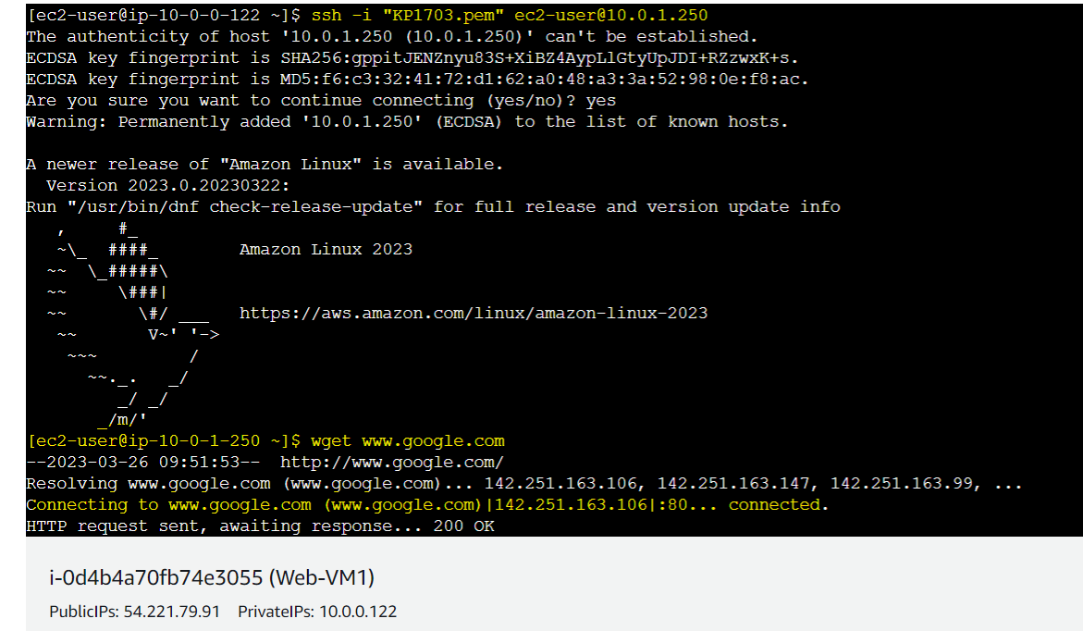

Due to NACL settings at subnet level for subnet App1, all the instances within subnet App1 will have internet connectivity:

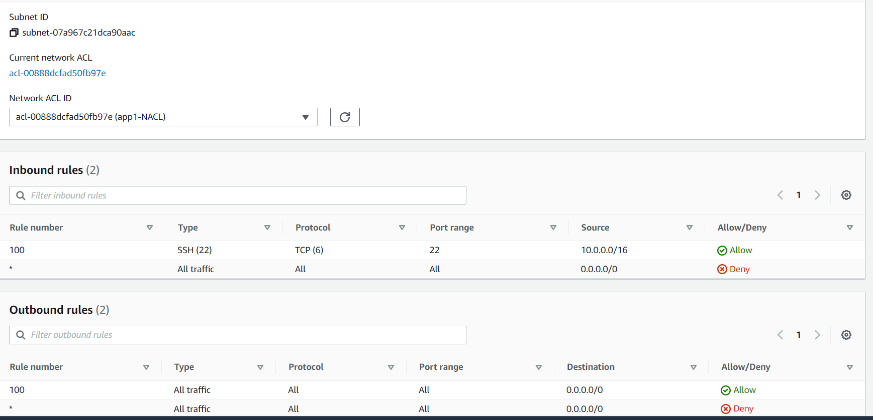

**Development Network:**

1. Design and build 2 tier architecture with two subnets named web and db and launch instances in both subnets and name them as per the subnet names.

2. Make sure only web subnet can send internet requests

3. Create peering connection between production network and development network

4. Setup connection between

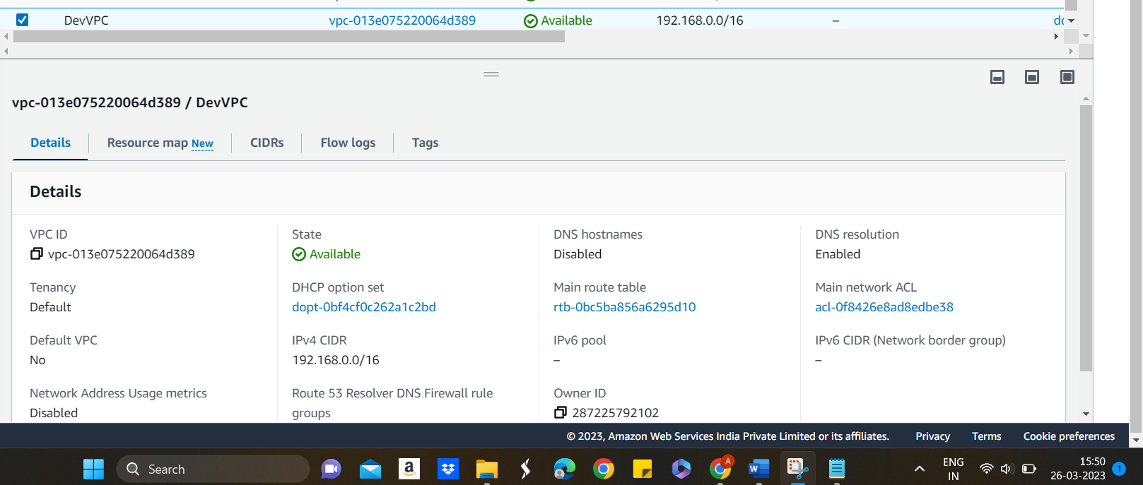

IGW RT associated only with WEB SN:

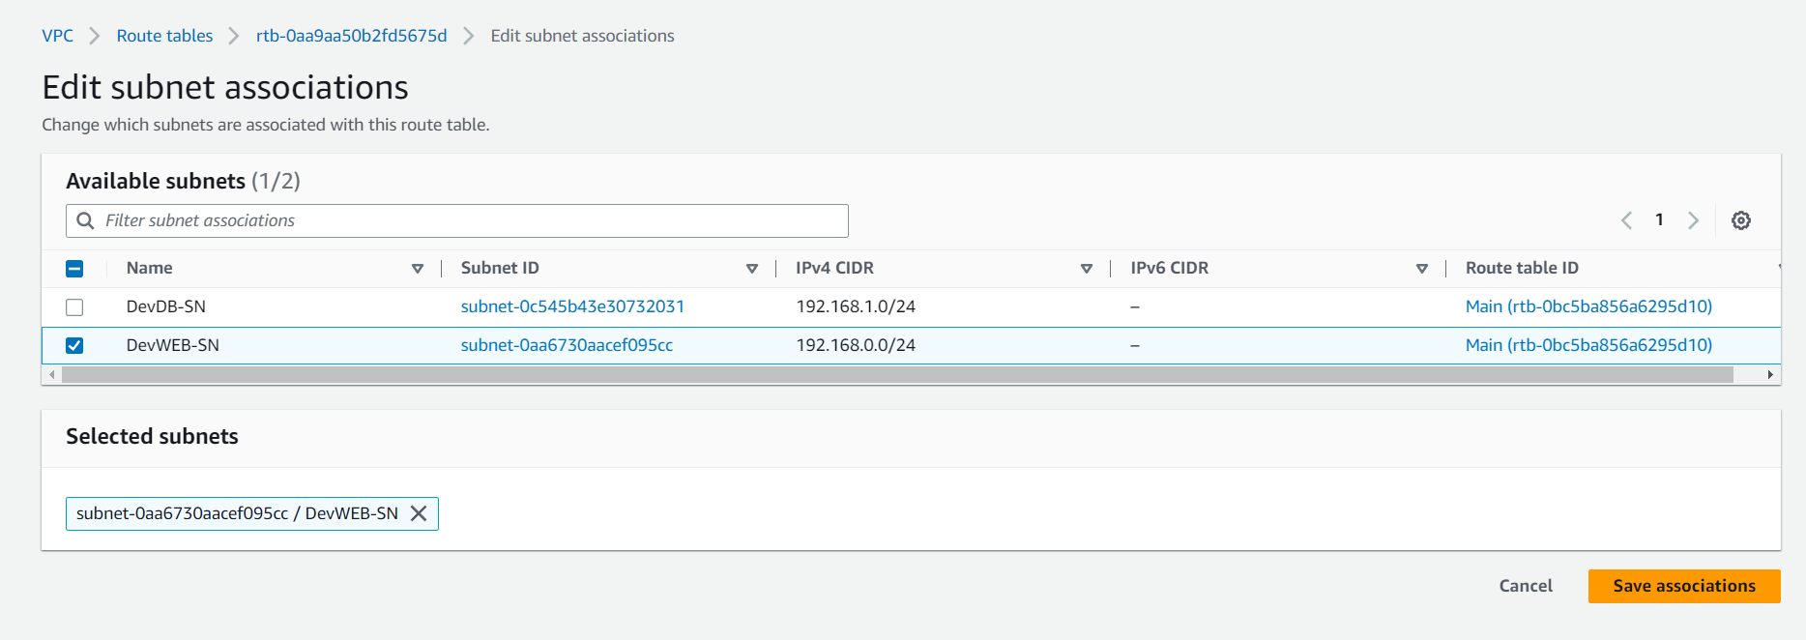

devVPC-Web1 instance is able to connect to Internet:

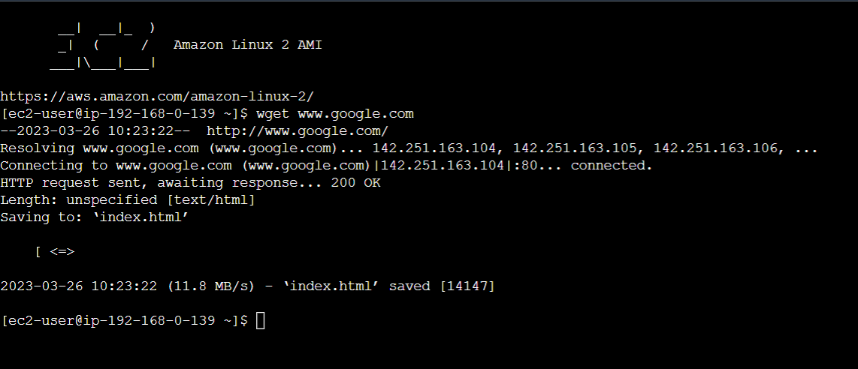

Creating peering connection between prod VPC and Dev VPC:

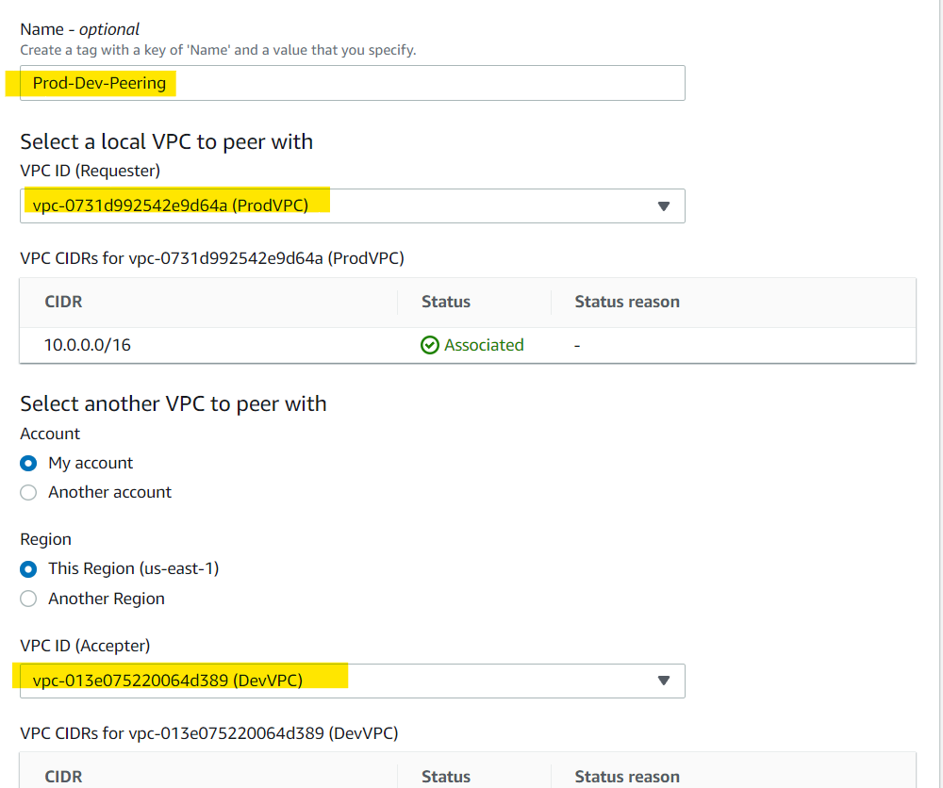

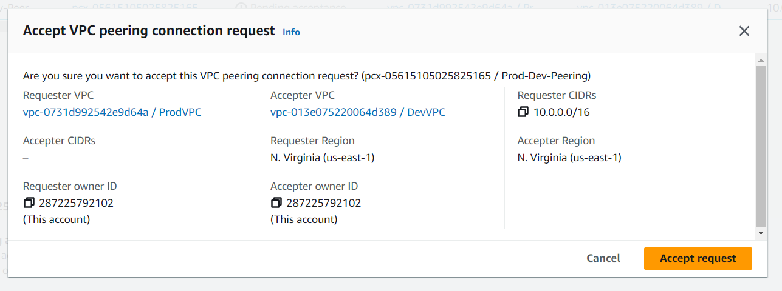

In order to establish connection between prod DB to Dev DB, creating Route tables with following settings:

Prod DB to Dev DB:

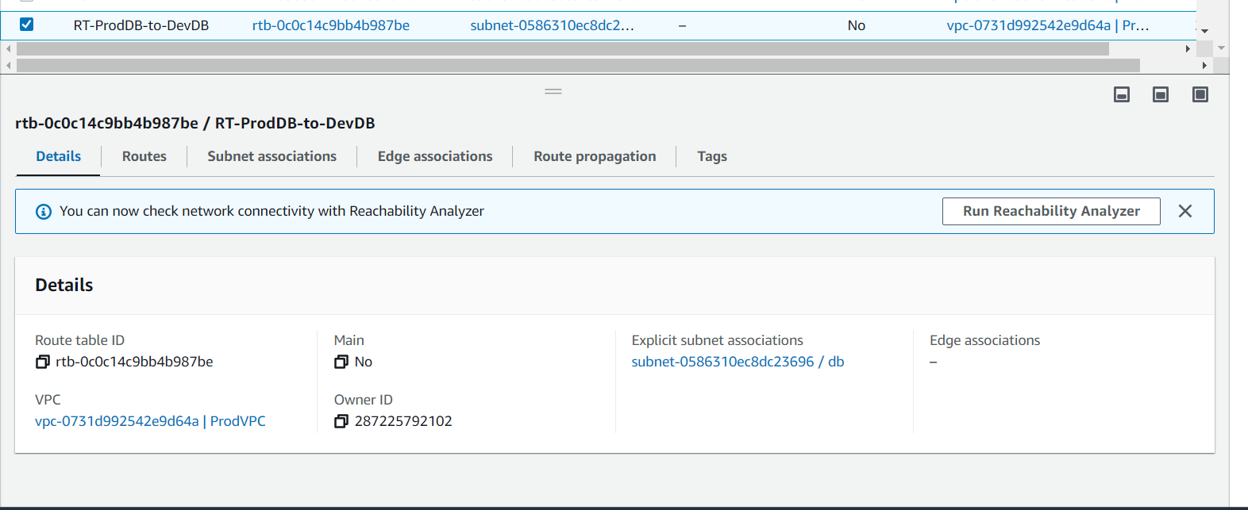

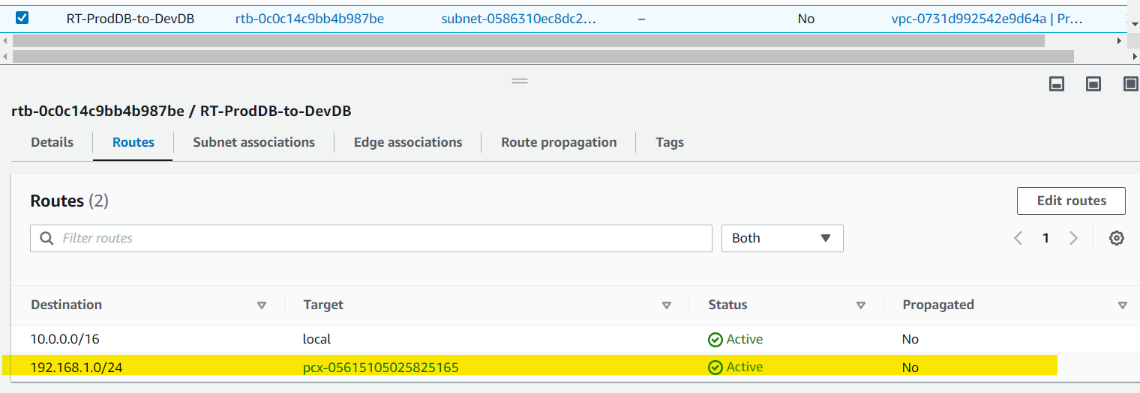

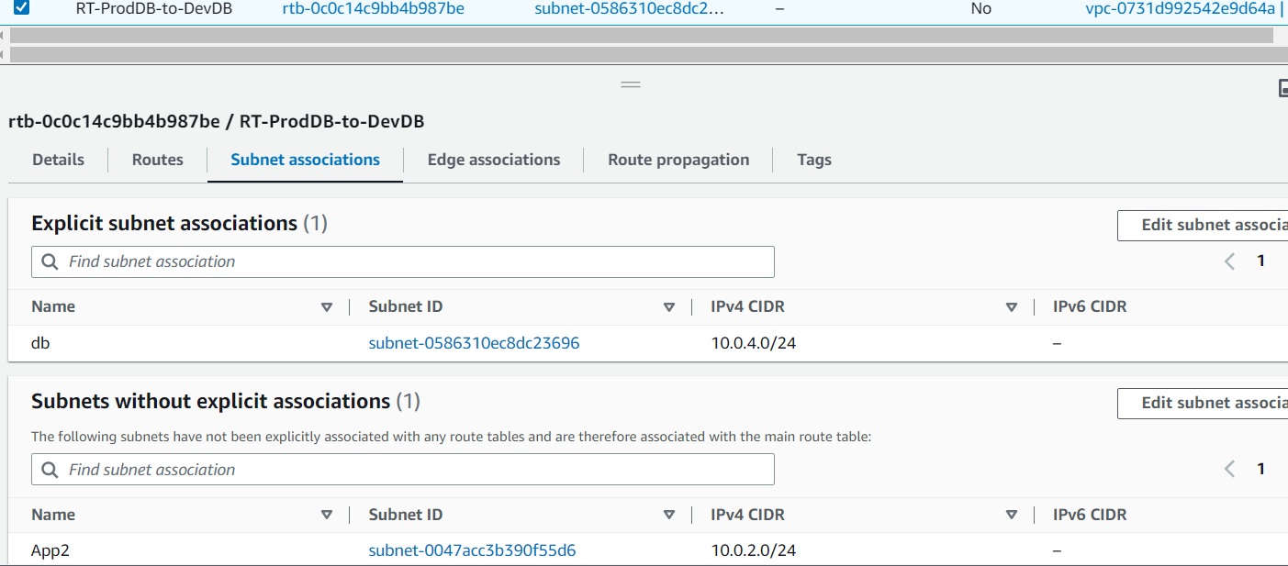

RT Dev DB to Prod Db:

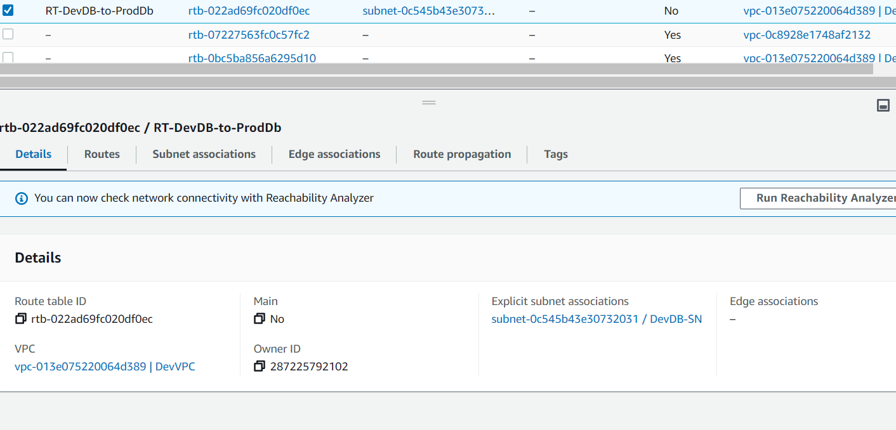

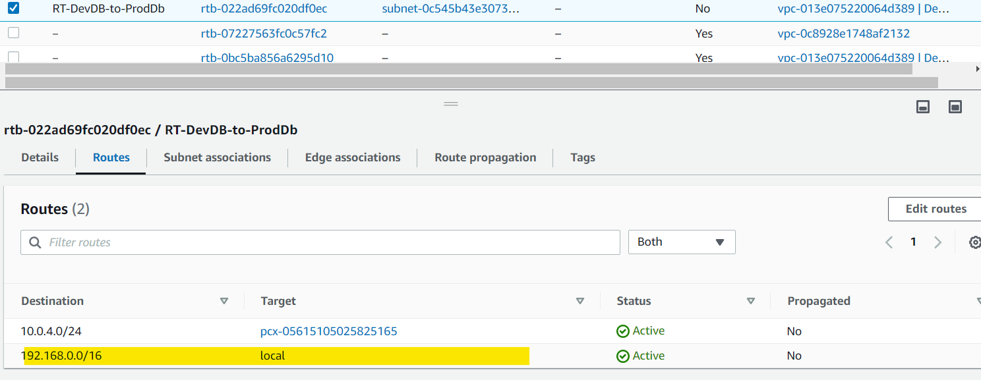

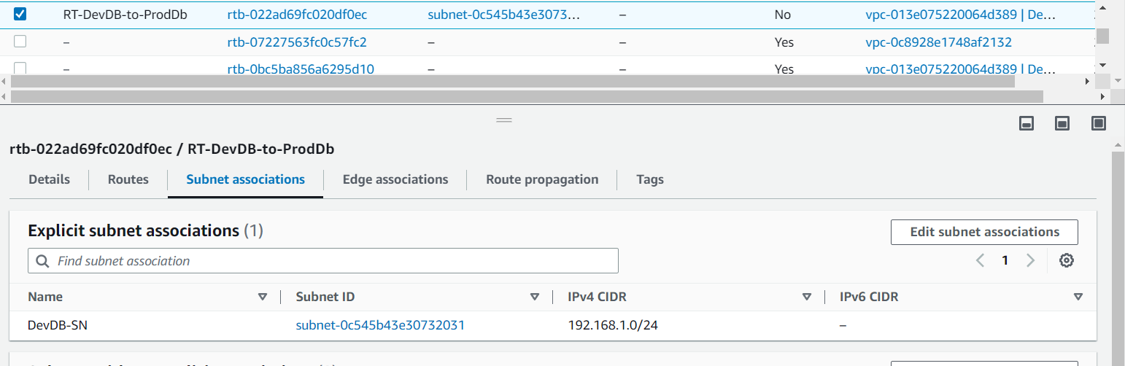

Connecting to ProdVPC-DB from DevVPC-DB instance:

Make sure if SG has correct inbound rules for Prod VPC DB:

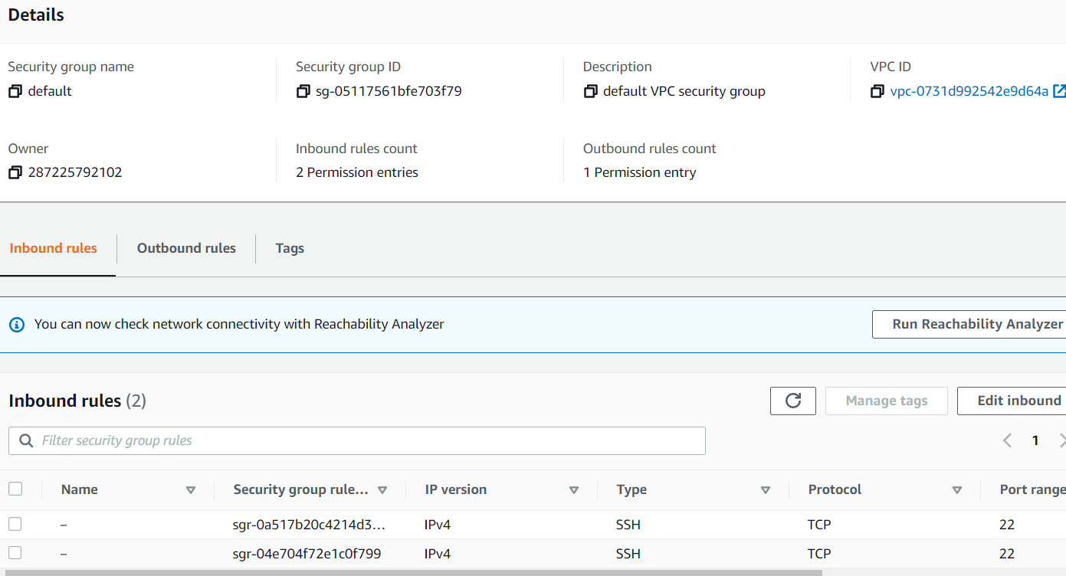

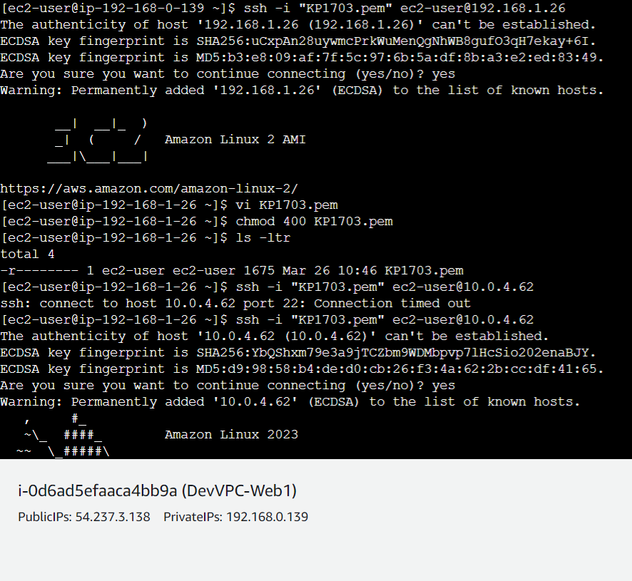

Connecting to Dev DB from Prod DB VM1:

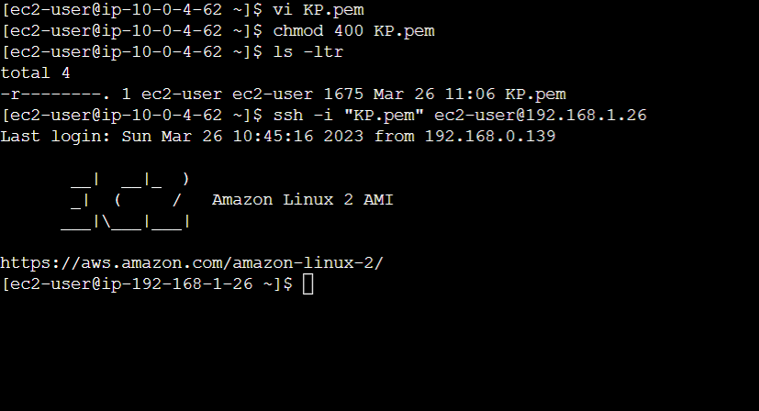

**VPC Assignment1**

You have been asked to:

1. Create a VPC with 120.0.0.0/16 CIDR block

2. Create 1 public subnet, 2 private subnets and make sure you connect a NAT gateway for internet connectivity to private subnet

**VPC**

Private SN

**0.0.0.0/0**

**Internet**

**IGW**

Private SN

**Cust RT**

Main RT

Public SN

1. Create a VPC with 120.0.0.0/16 CIDR block

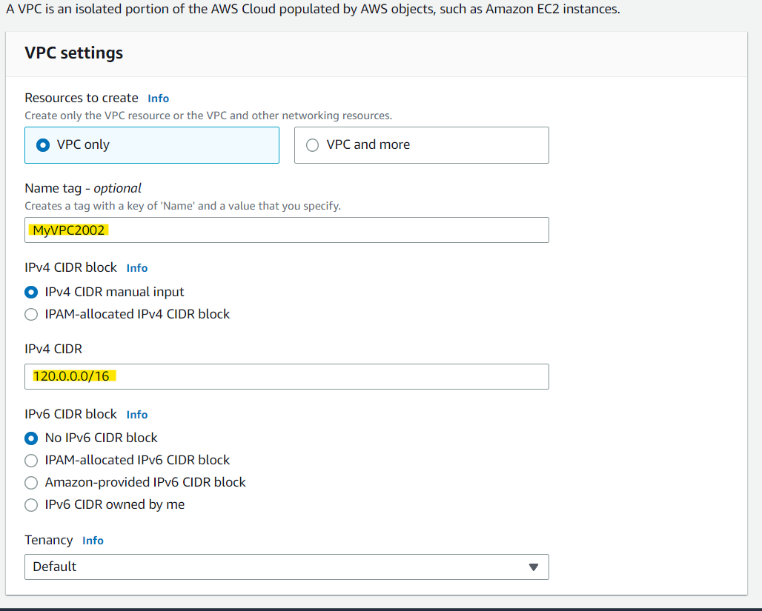

1. Create 1 public subnet, 2 private subnets and make sure you connect a NAT gateway for internet connectivity to private subnet

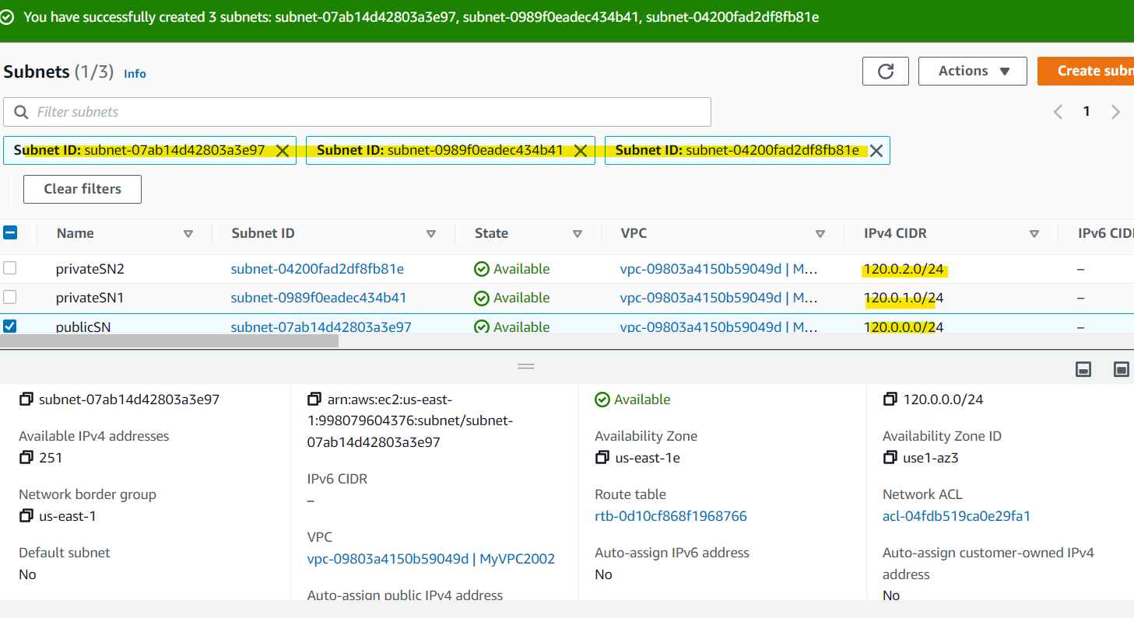

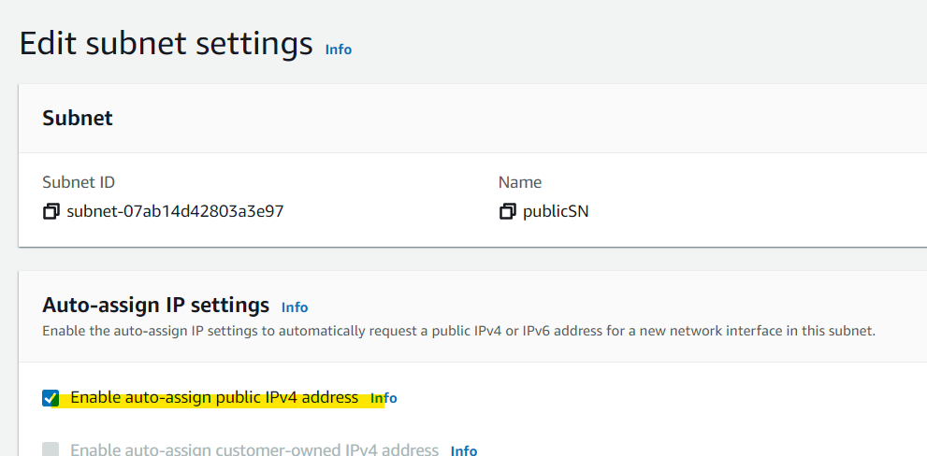

IGW creation:

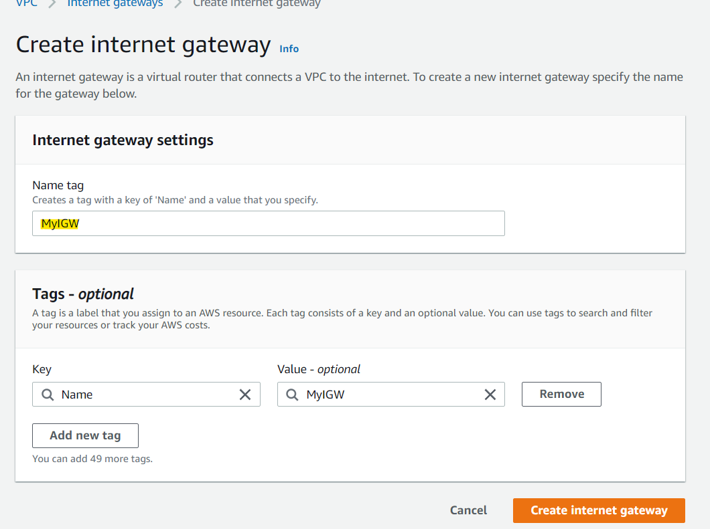

Attaching:

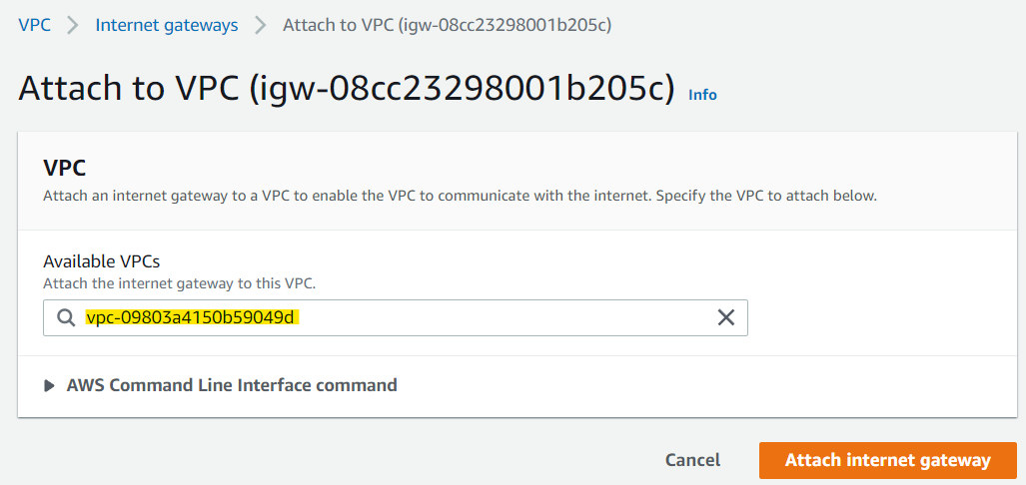

Custom Route table

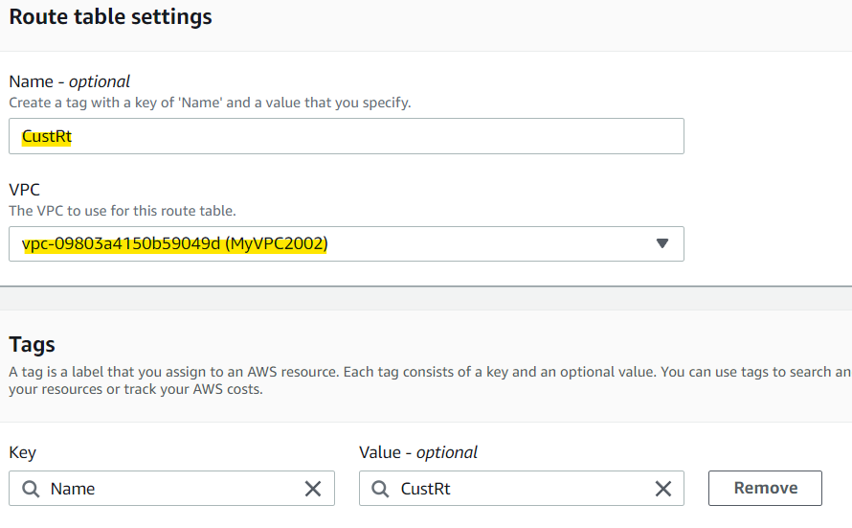

Attaching to MyIGW

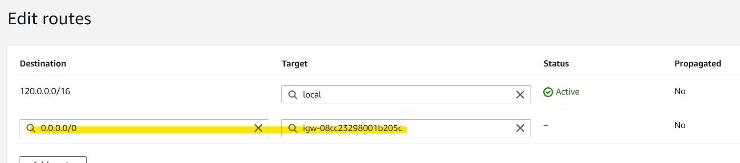

VM Creation:

In Public SN

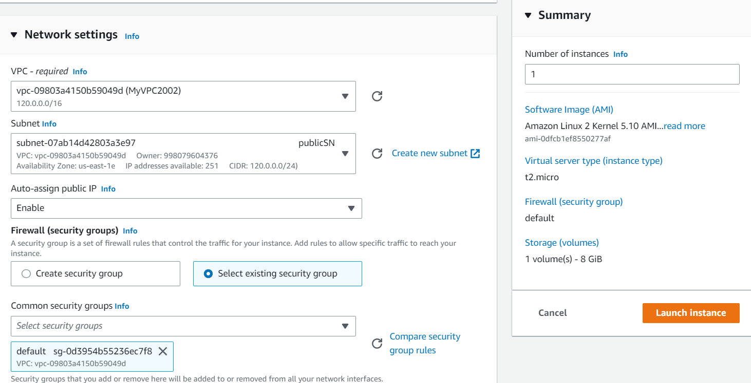

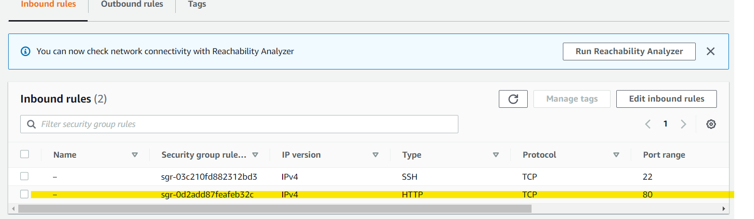

In Private SN1:

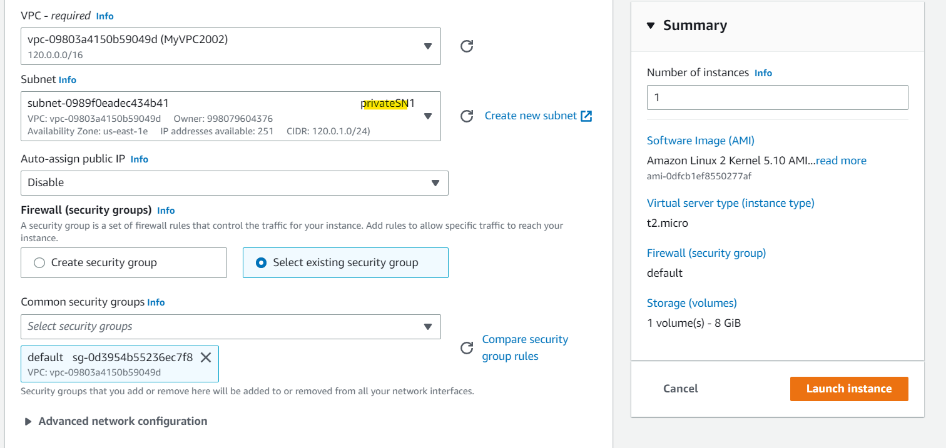

In private SN2:

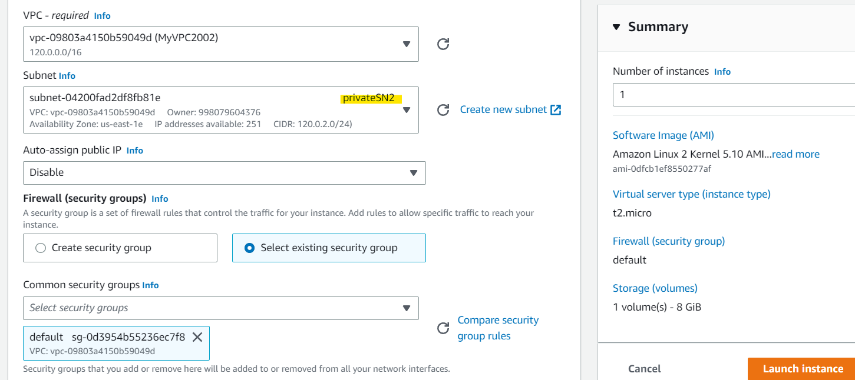

Internet Accessible from PublicVM:

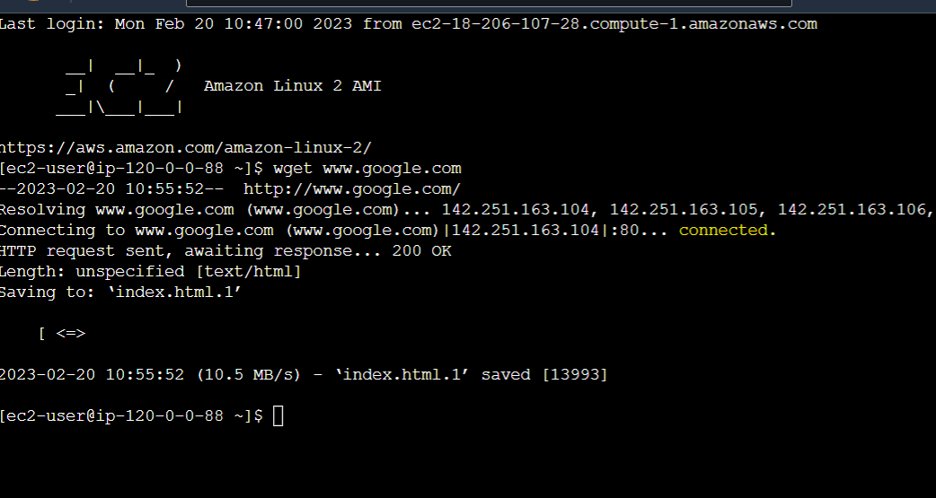

Copying pem to public VM:

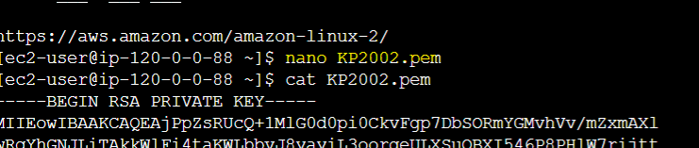

Creating NAT Gateway:

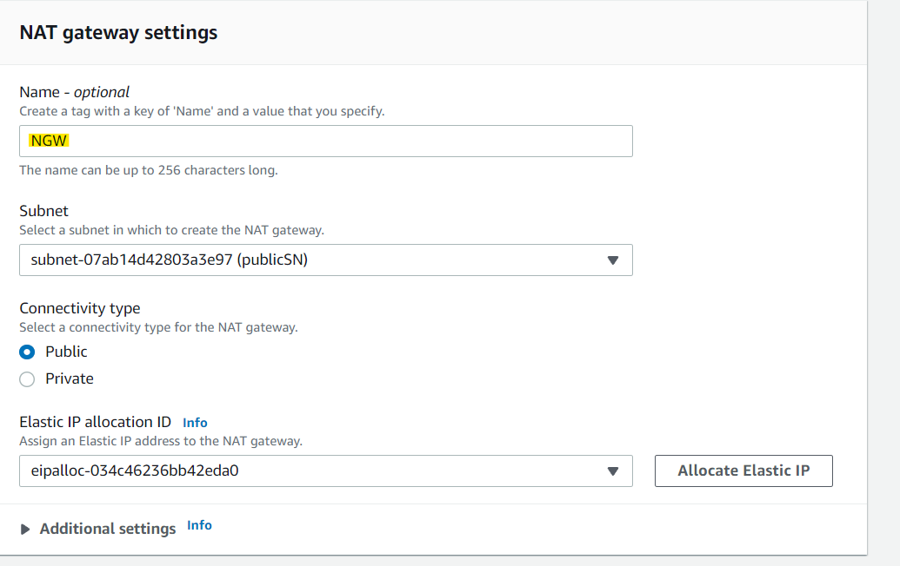

Route table;

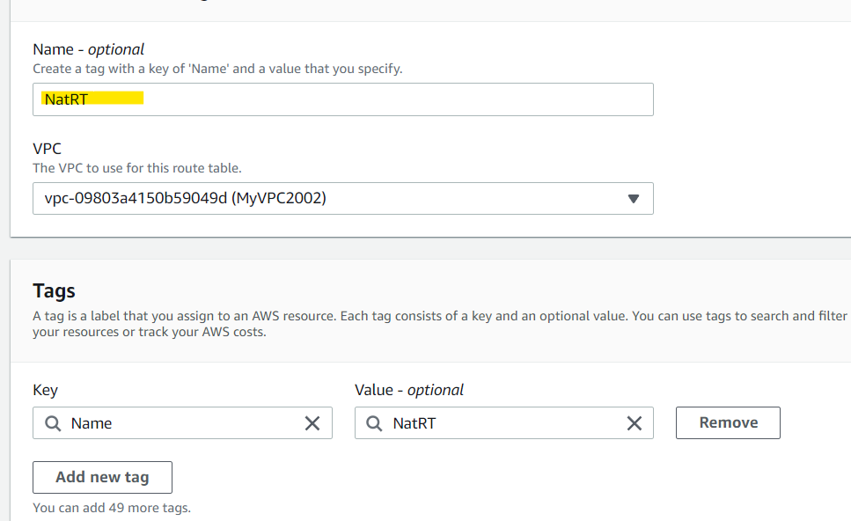

Edit route;

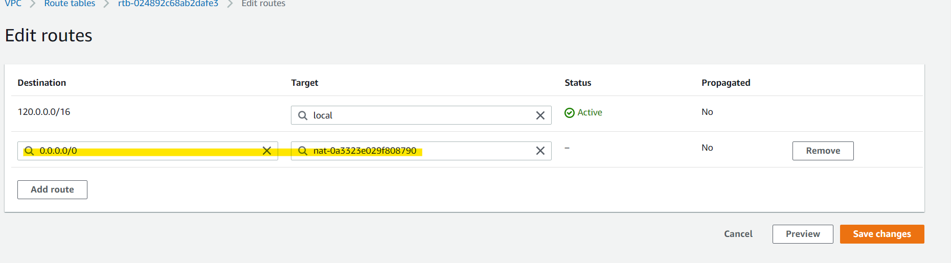

Private subnet association:

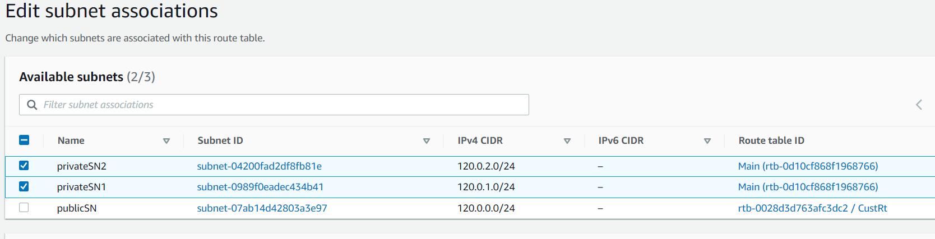

Able to connect through private vm:

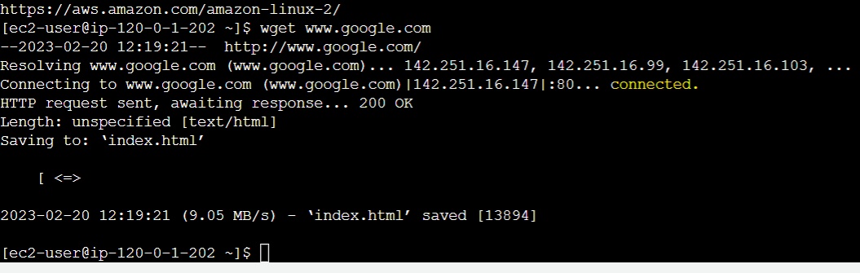

**VPC Assignment2**

1. Create 2 VPCs in the North Virginia region named MYVPC1 and MYVPC2

2. Create one VPC in Oregon region named VPCOregon1

3. Create a peering connection between MYVPC1 and MYVPC2

4. Create a peering connection between MYVPC2 and VPCOregon1

1. Create 2 VPCs in the North Virginia region named MYVPC1 and MYVPC2

MYVPC1:

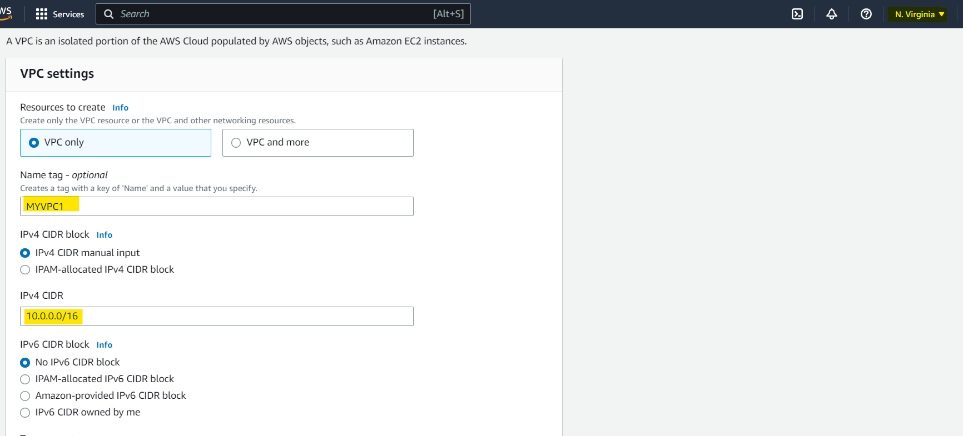

MyVPC2:

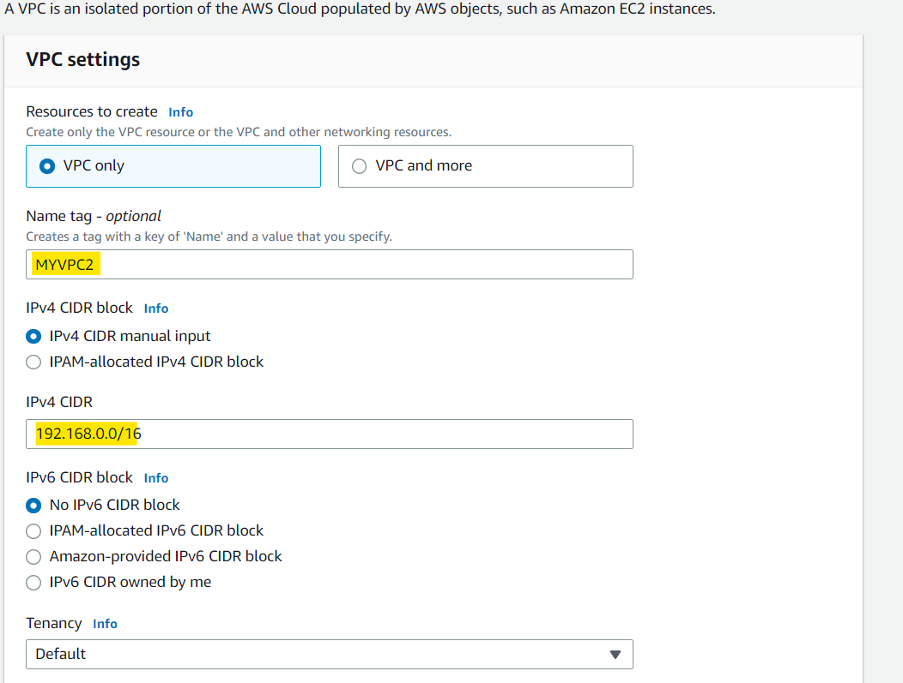

2. Create one VPC in Oregon region named VPCOregon1

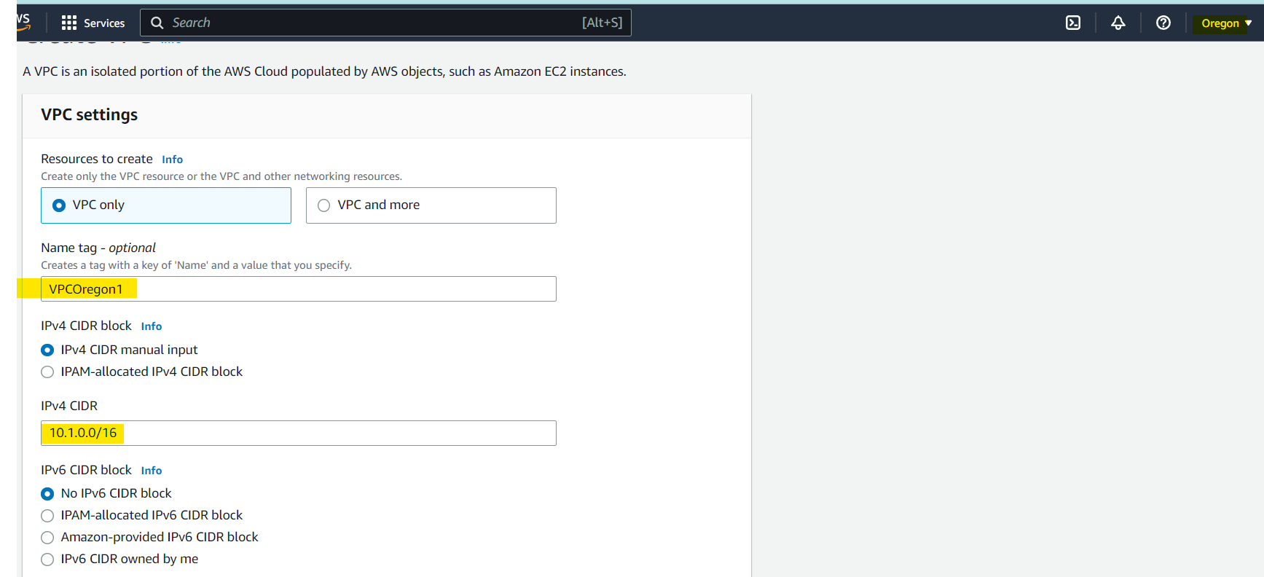

3. Create a peering connection between MYVPC1 and MYVPC2

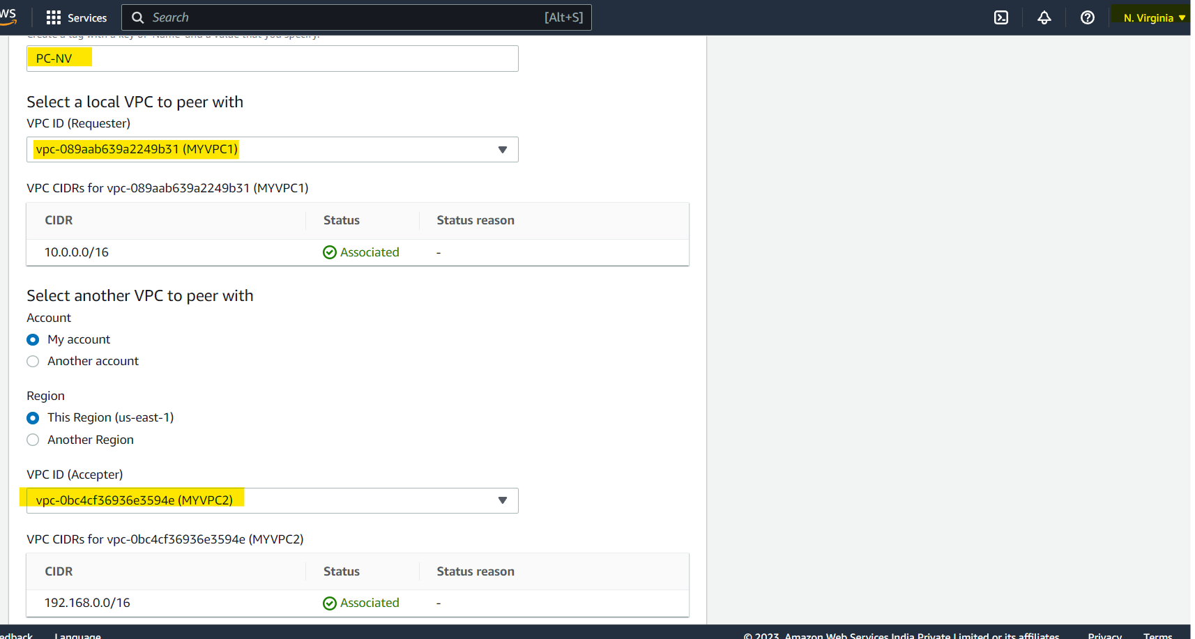

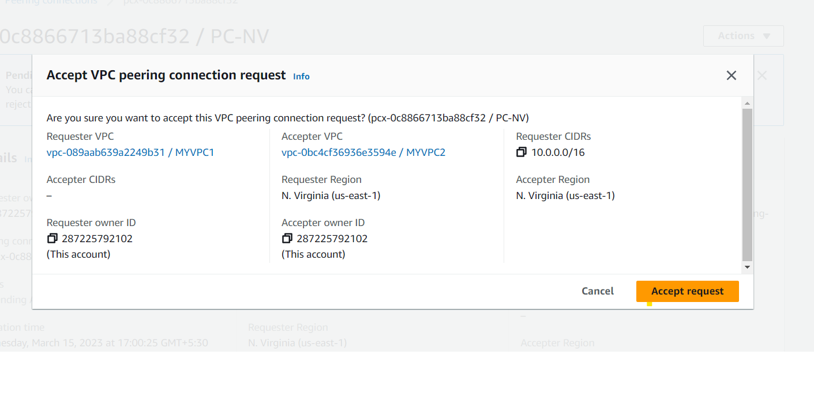

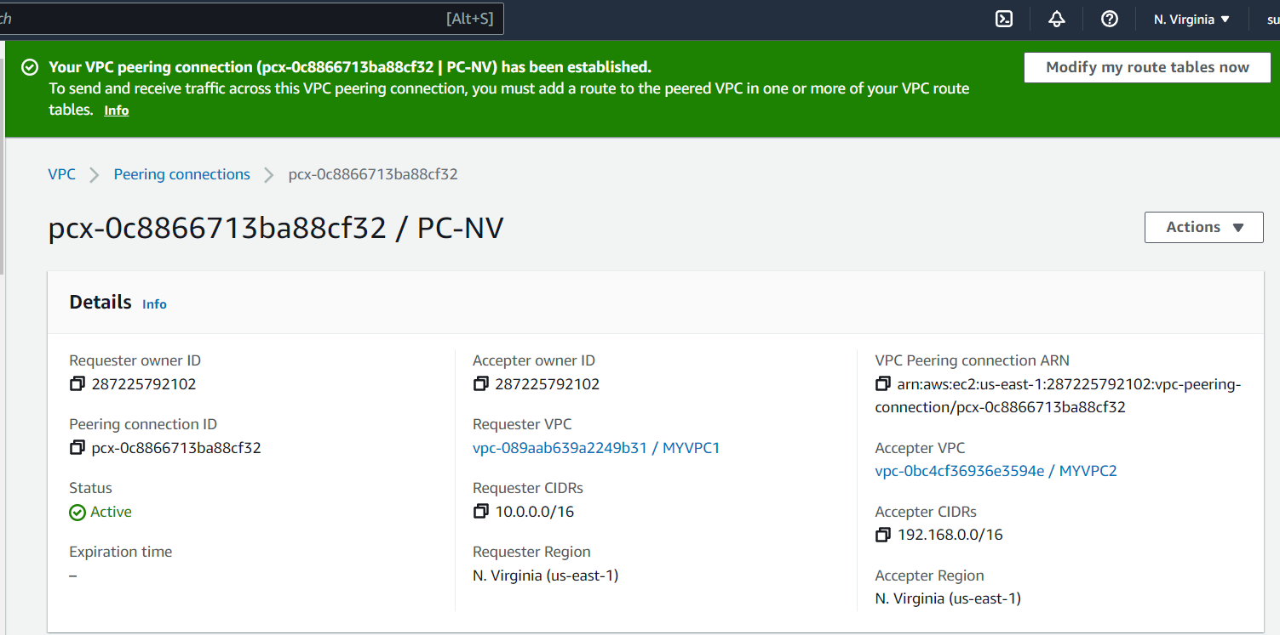

4. Create a peering connection between MYVPC2 and VPCOregon1

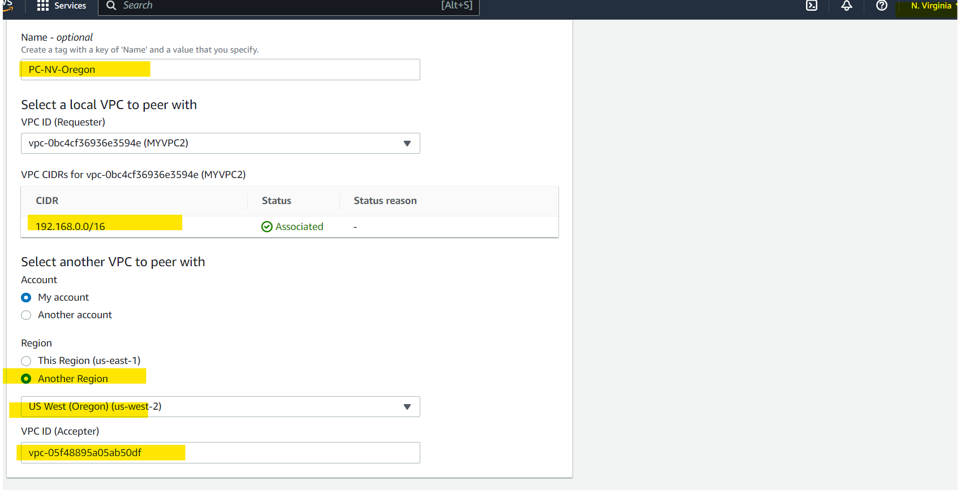

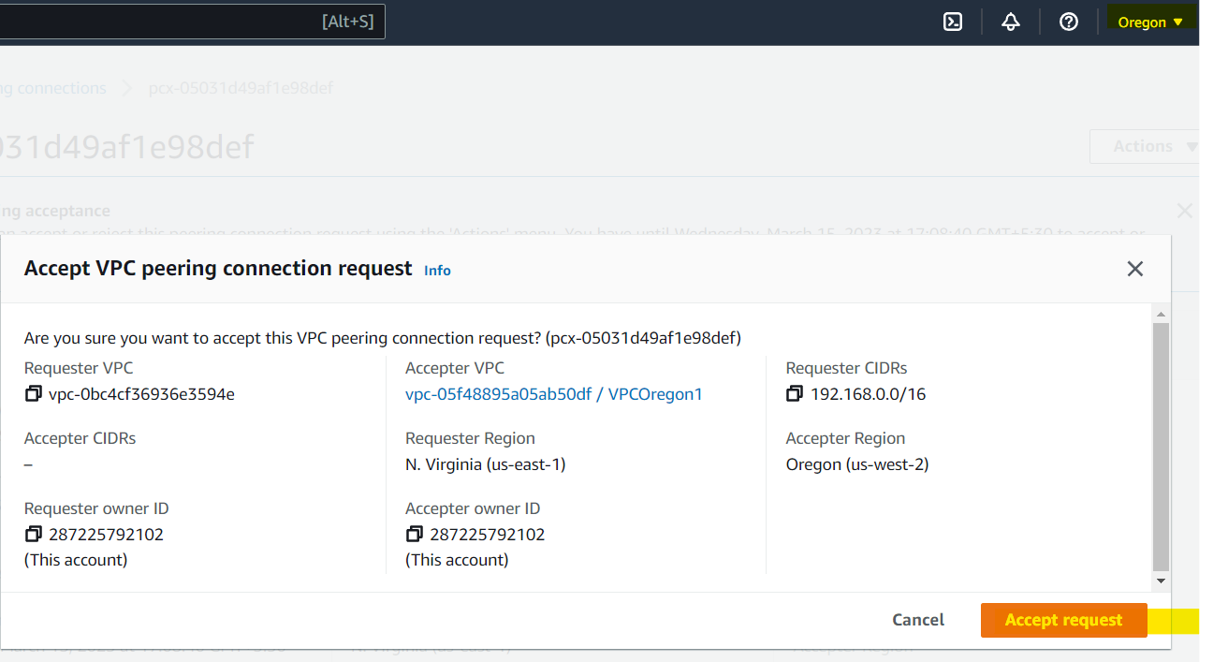

Peering connections Established between VPC1 and VPC2 in NV region with PC-NV peering connection

And between MYVPC2 and VPCOregon1 with PC-NV-Oregon Peering Connection:

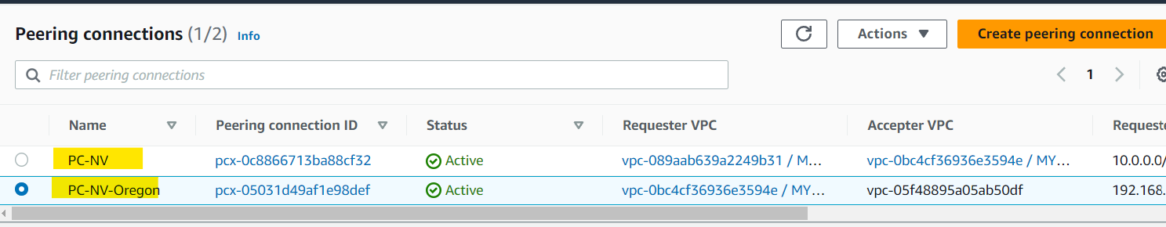

**VPC Assignment3**

1. Create a VPC Endpoint for an S3 bucket of your choice

1. VPC Creation:

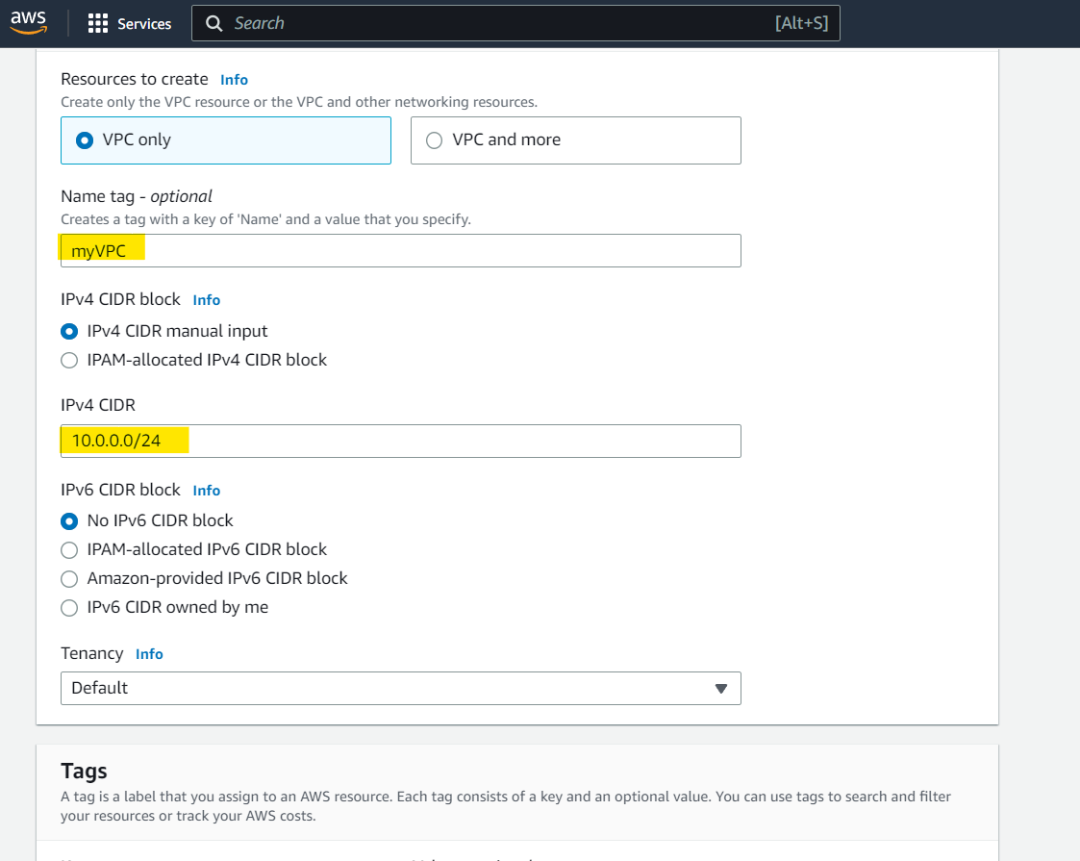

1. Subnet Creation:

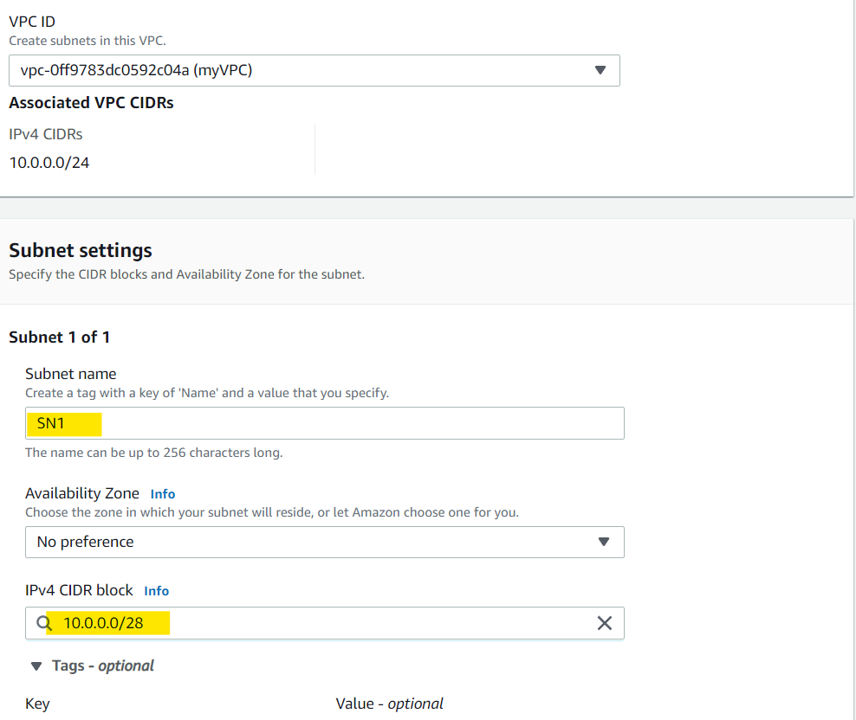

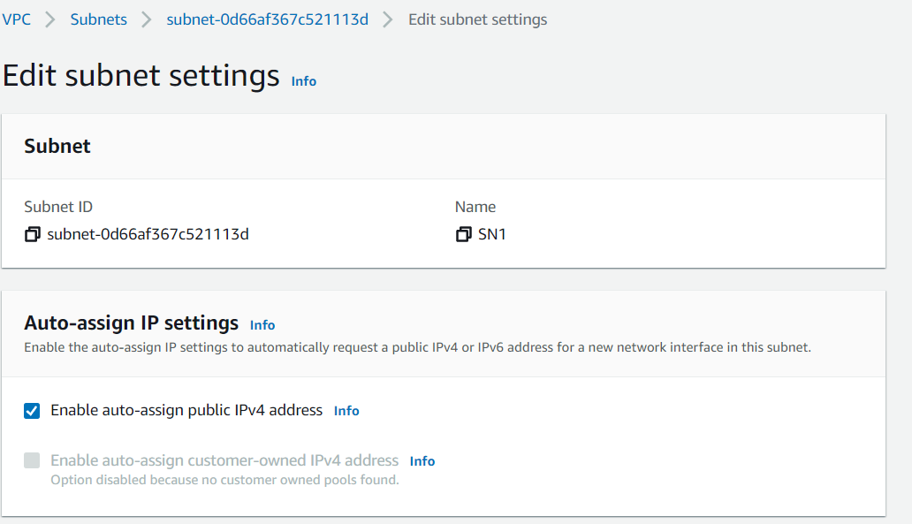

1. Internet Gateway creation to connect instances :

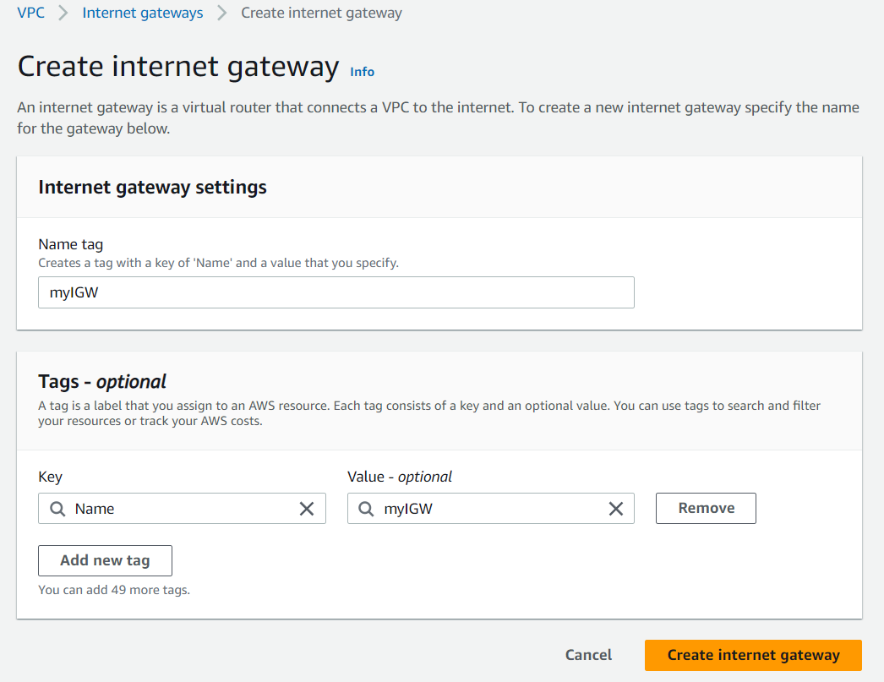

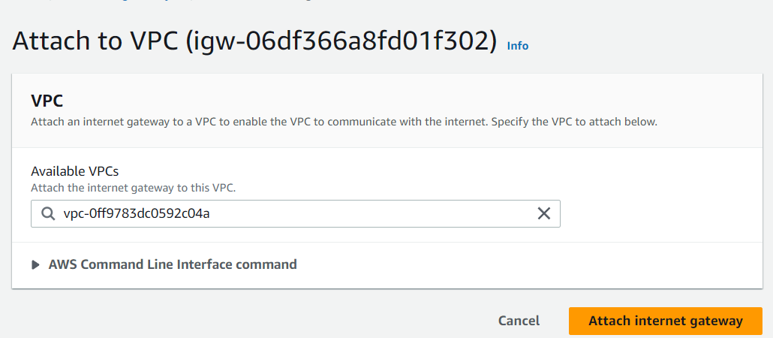

1. Route Table Creation for internet connectivity through IGW:

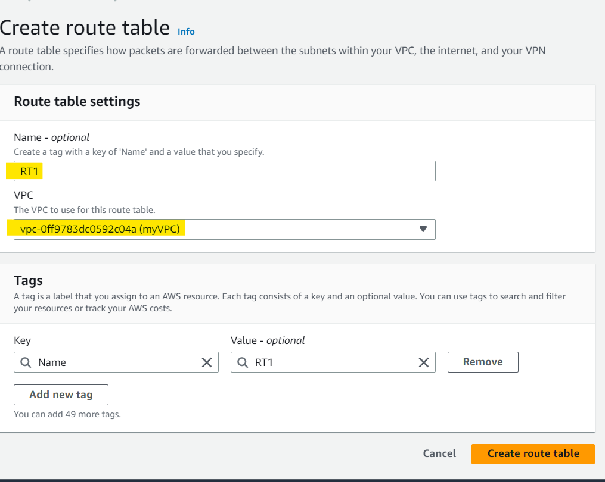

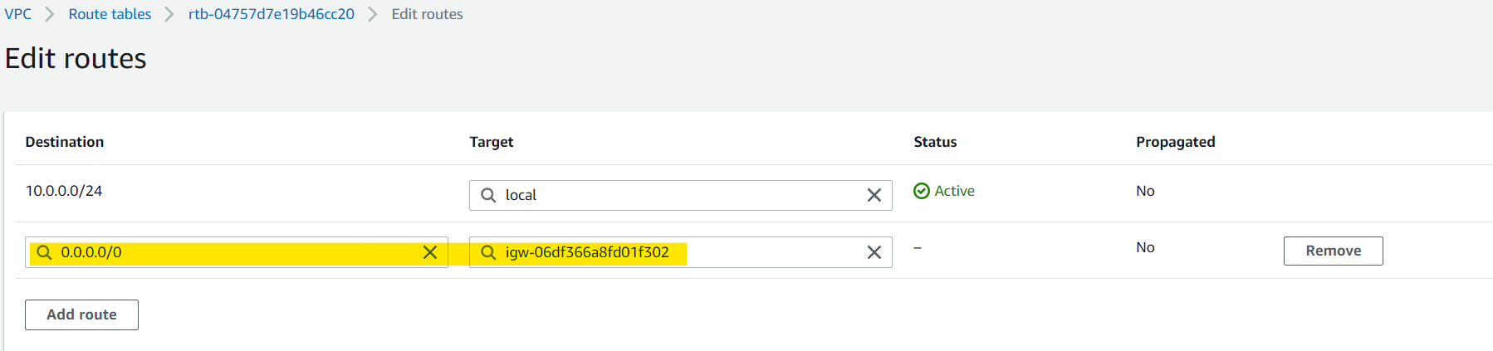

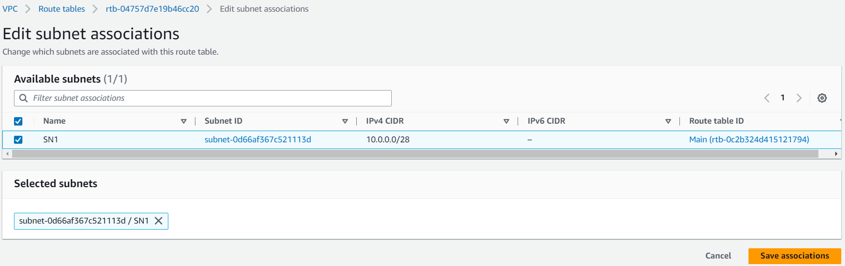

1. EC2 Instance Creation:

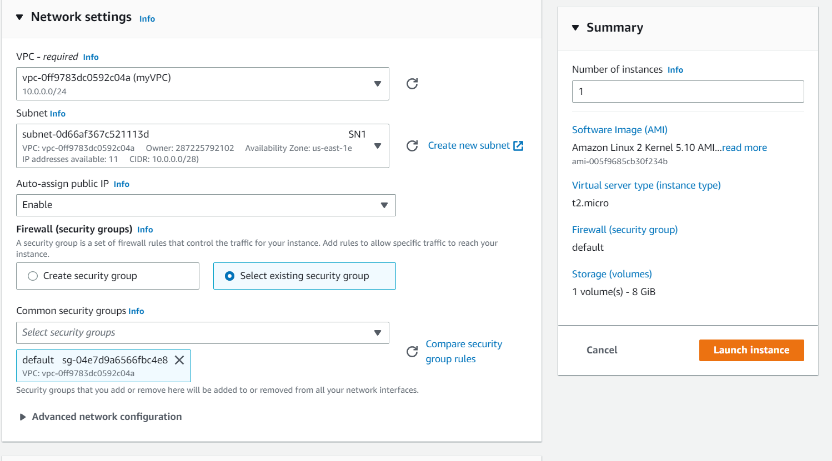

1. Deleting the old SG inbound rules and adding new rule as below:

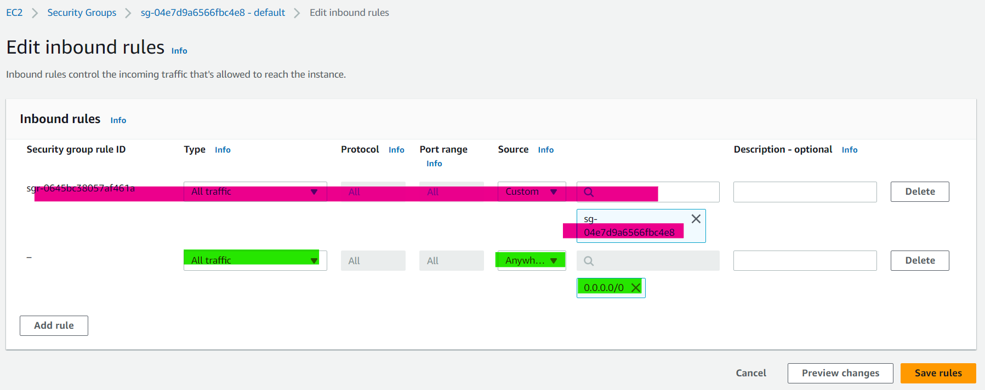

1. Connecting to EC2 and trying to connect S3 (which will fail)

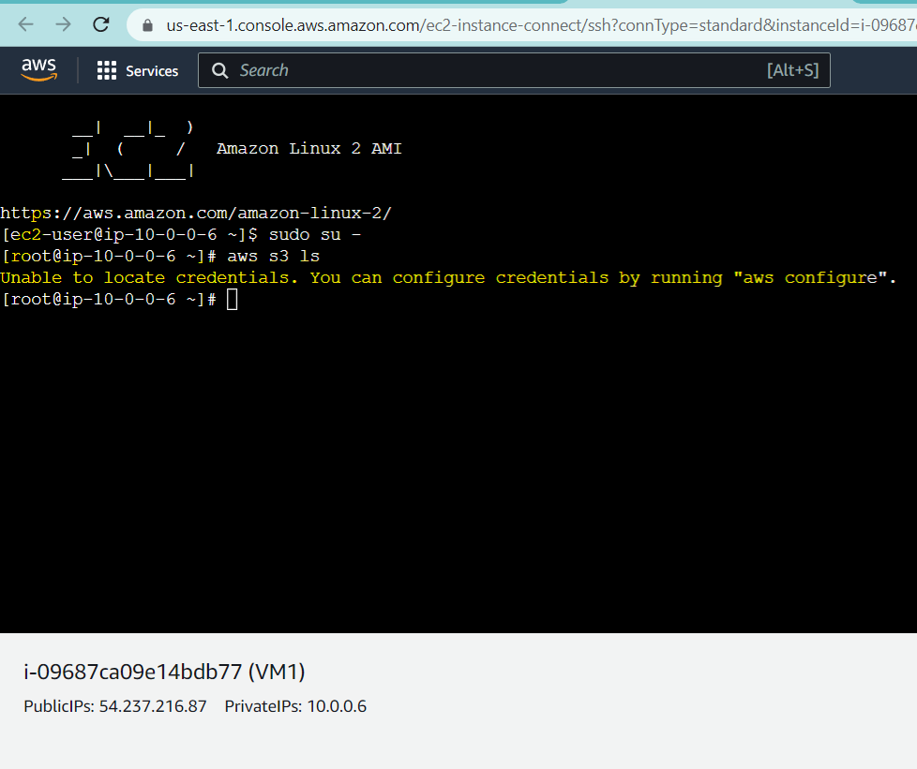

1. Endpoint Creation:

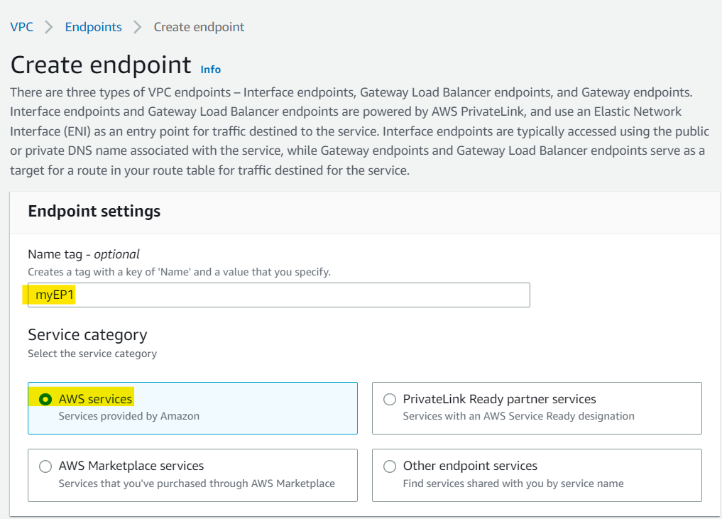

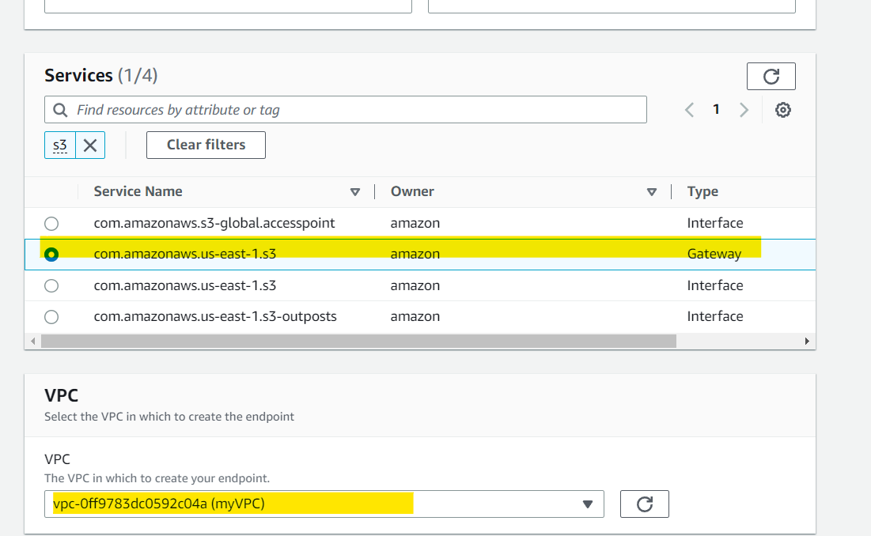

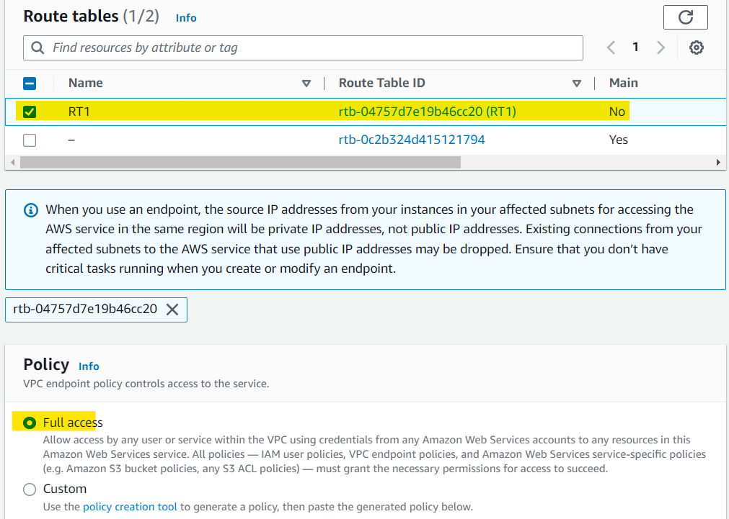

1. IAM Role Craetion:

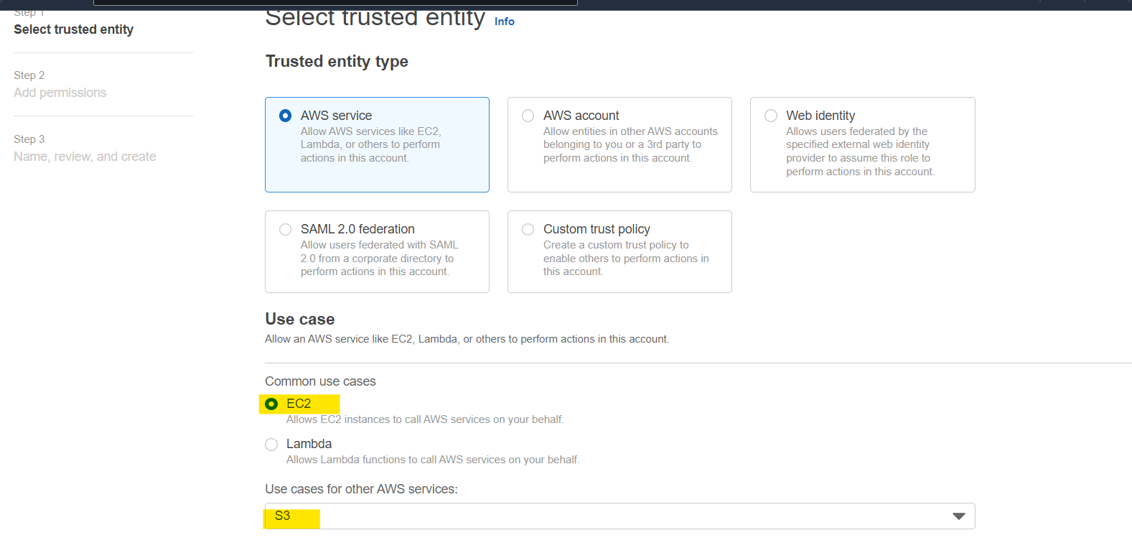

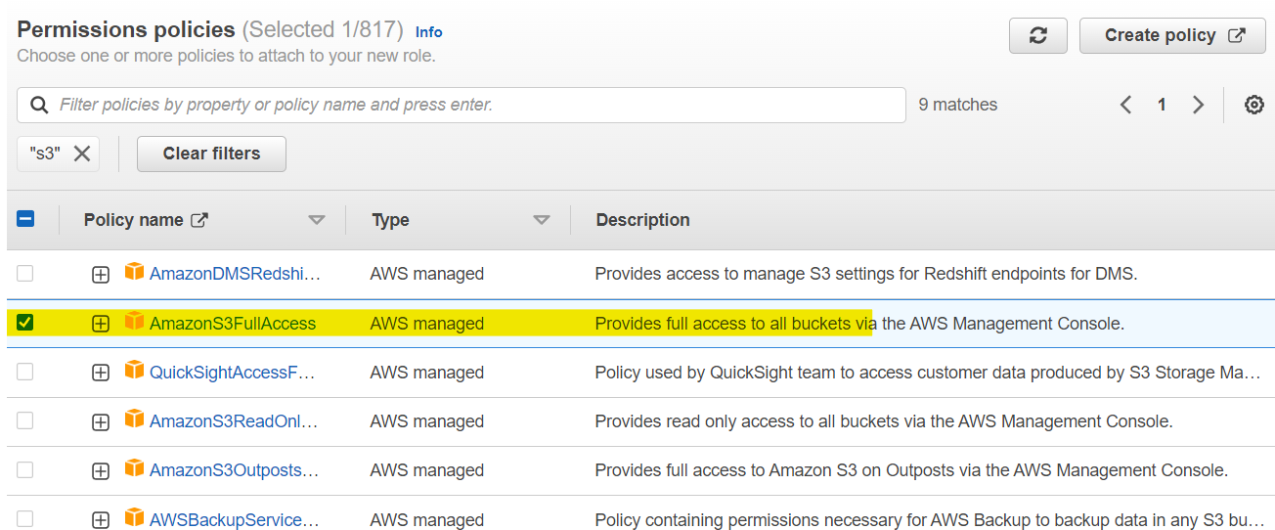

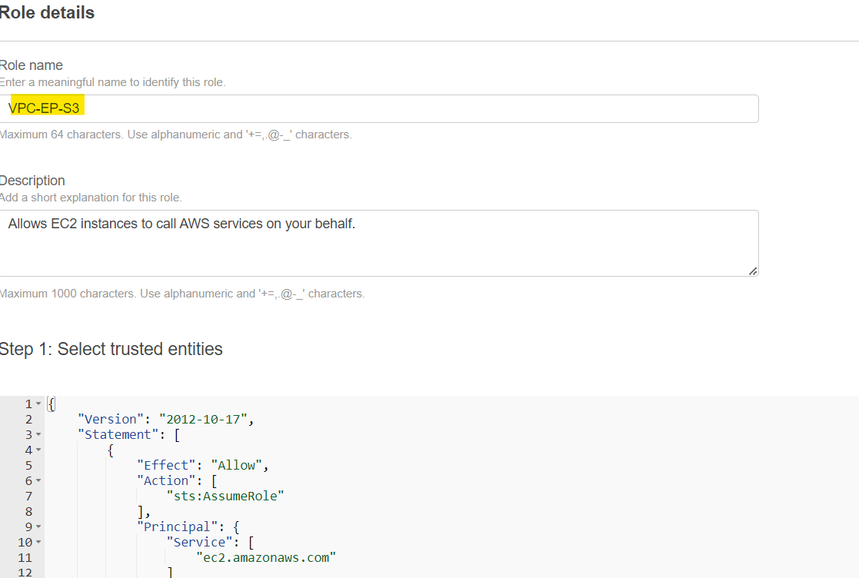

Updating IAM role for EC2:

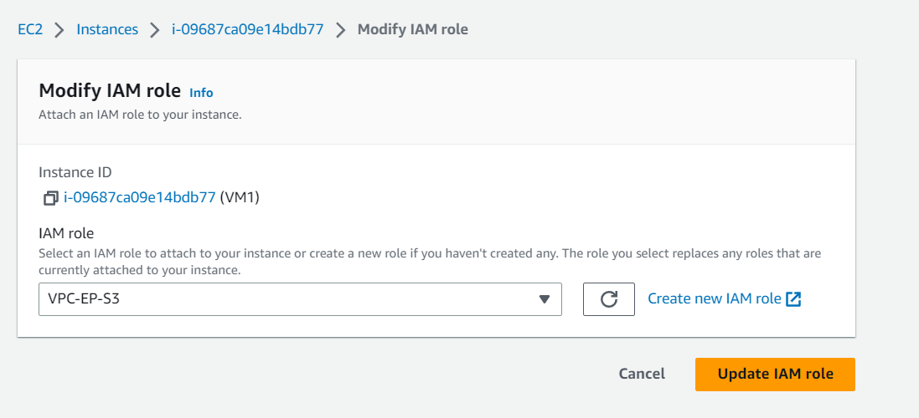

Creating S3 Bucket:

Uploading File from Instance to bucket:

